**EliteShoppy**

An E-Commerce website

for clothing

Autor: **Martin Birišić**

Predmet: **Web programiranje PHP1**

Smer: **Internet Tehnologije**

Godina: **II**

Index: **22/21**

2023-5-12

Contents

Uvod 3

Korisceni programski jezici i biblioteke: 3

Opis funkcionalnosti: 3

Template: 4

Šema baze: 4

Slike stranica i opisi funkcionalnosti: 4

INDEX.PHP -> modal za registraciju 4

INDEX.PHP -> modal za logovanje 5

INDEX.PHP?page=home 6

INDEX.PHP?page=shop 7

INDEX.PHP?page=about 8

INDEX.PHP?page=contact 9

INDEX.PHP?page=profile 10

INDEX.PHP?page=admin_panel 11

INDEX.PHP?page= insert-articles_genders 12

INDEX.PHP?page= edit-articles&id=3 13

Kodovi: 13

PHP 13

JAVASCRIPT 127

CSS 138

# Uvod

## Korisceni programski jezici i biblioteke:

* HTML
* CSS
* BOOTSTRAP
* JAVASCRIPT
* JQUERY
* PHP
* MYSQL

## Opis funkcionalnosti:

* Sajt demonstrira rad online prodavnice odece
* Ostvaren je u vidu Single Page aplikacije
* Koristi se MVC struktura foldera
* Na index strani sadrzi sistem rutiranja u zavisnosti od postavljene stranice koju dobija iz query stringa URL adrese
* Sadrzi sistem registracije i logovanja korisnika
* Dinamicki meni sa linkovima ka stranicama odredjenim ulogom korisnika
* Kontakt forma preko koje korisnik salje poruku adminu na mail
* Svaka forma (login, register, kontakt) ima validaciju podataka I putem AJAX-a omogucava slanje HTTP zahteva ka serveru i odgovore sa istog u vidu response kodova i custom poruka
* Forme, kao i druge privilegovane stranice, sadrze zastitu od neovlascenog pristupa i pristupa preko URL adrese
* Forme za register i login se onemogucavaju ako je korisnik ulogovan
* Shop stranicu na kojoj moze da pretrazuje, filtrira i sortira dostupne artikle
* Dinamicki generisane stranice sa detaljnijim informacijama o izabranom artiklu
* Sadrzi Admin panel stranicu iskljucivo za administratora sajta
* Panel omogucava korisnicima koji nisu programeri da administriraju sajtom kroz jednostavan korisnicki interfejs
* U njemu se mogu raditi CRUD operacije nad svim kljucnim tabelama u bazi podataka

## Template:

<https://w3layouts.com/template/elite-shoppy-ecommerce-category-bootstrap-responsive-web-template/>

## Šema baze:

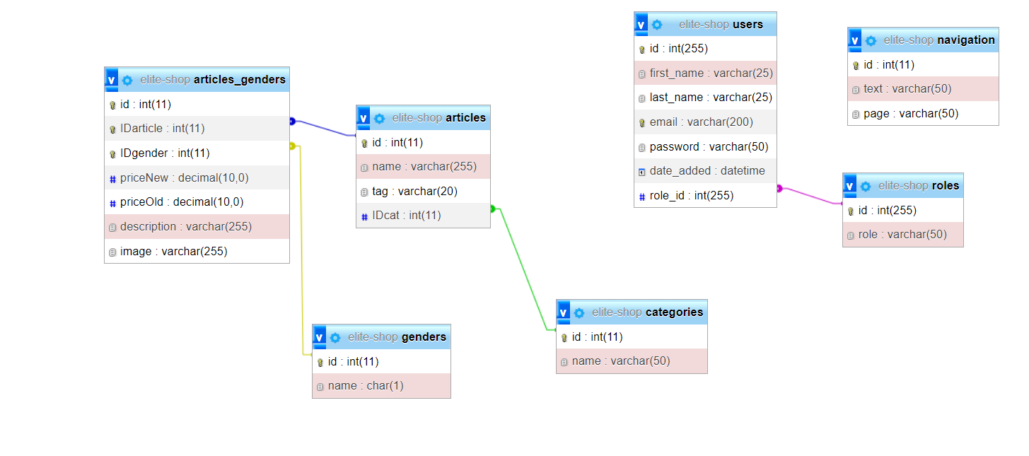

## Slike stranica i opisi funkcionalnosti:

### INDEX.PHP -> modal za registraciju

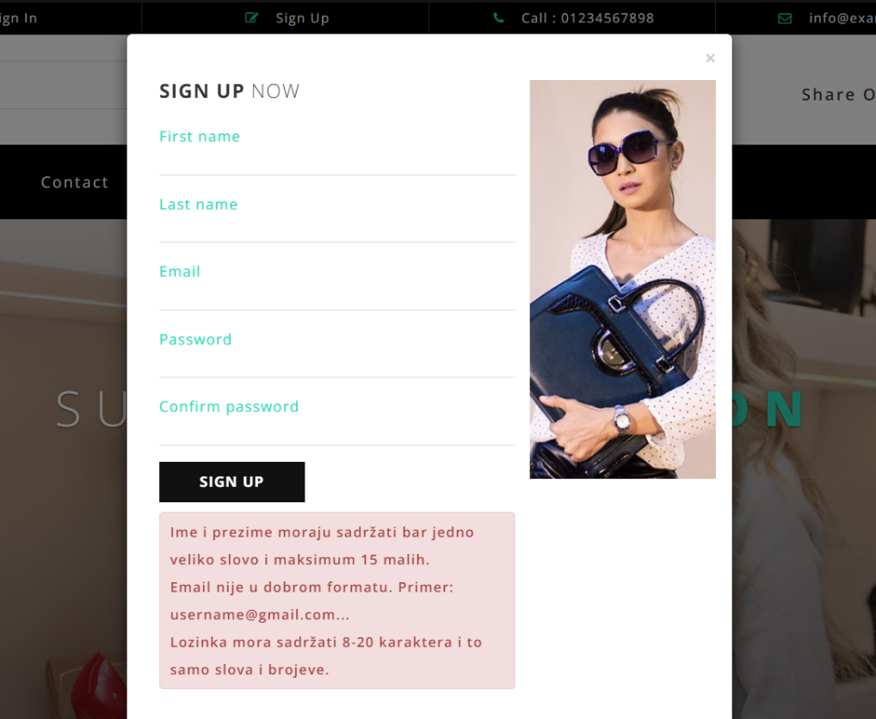

Sekcija za ispis poruka o greskama ili uspesnom unosu

Forma za registraciju novih korisnika; po defaultu dobijaju rolu “buyer”

### INDEX.PHP -> modal za logovanje

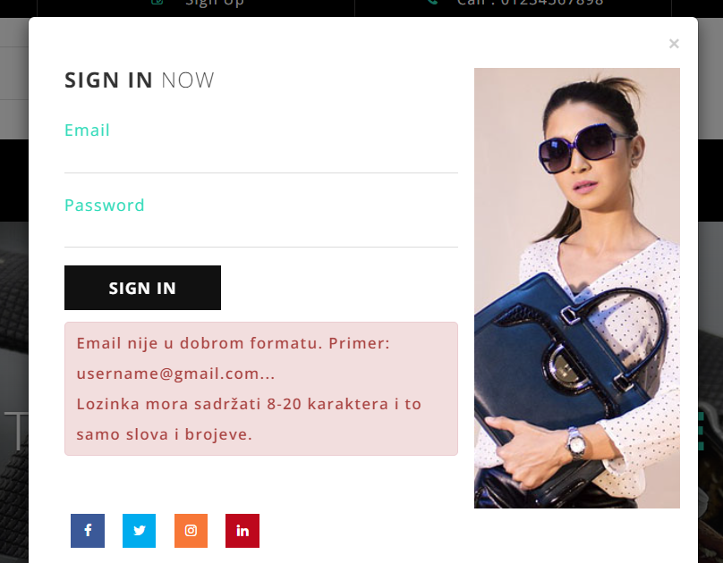

Slican princip kao I registracija koja, u sustini, po unosu u bazu takodje odradi I login

### INDEX.PHP?page=home

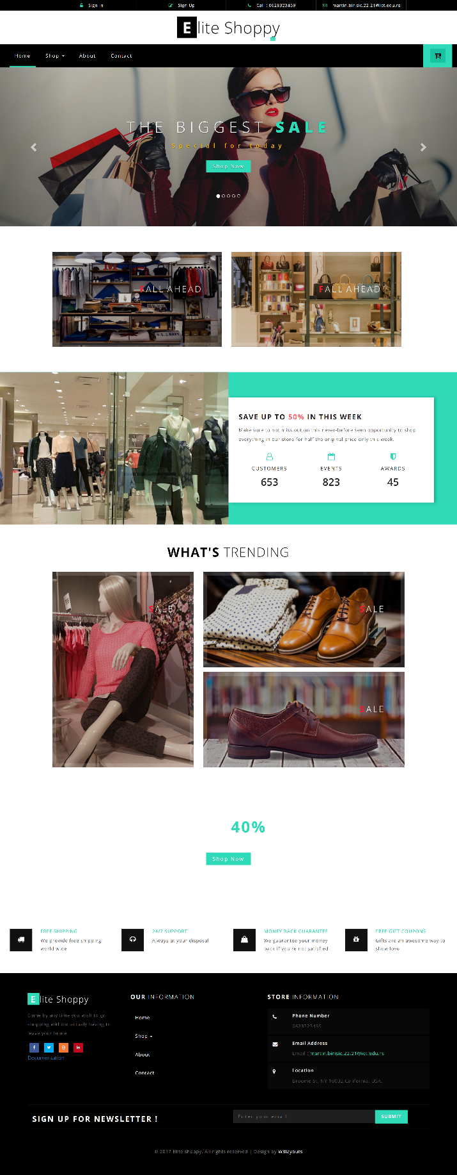

Pocetna stranica

### INDEX.PHP?page=shop

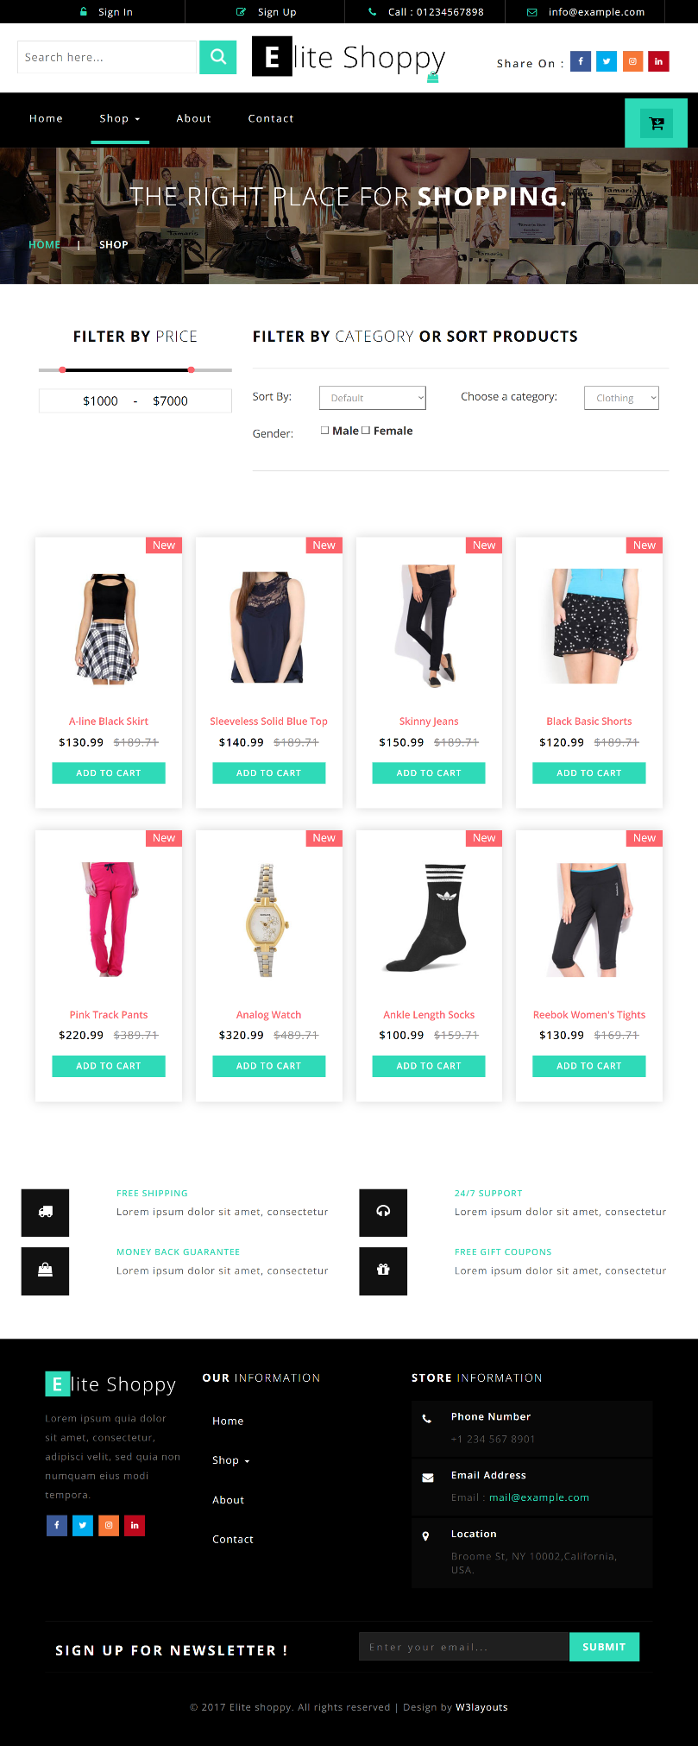

Dinamicki ispisani proizvodi

Paleta sa filterima i sortovima

Search filter

Dinamicki meni

Dinamicki meni

### INDEX.PHP?page=about

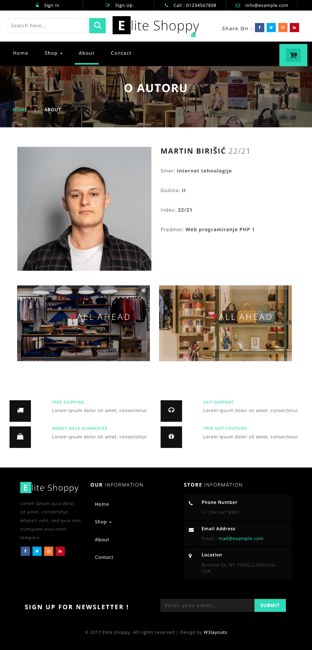

Stranica o autoru

### INDEX.PHP?page=contact

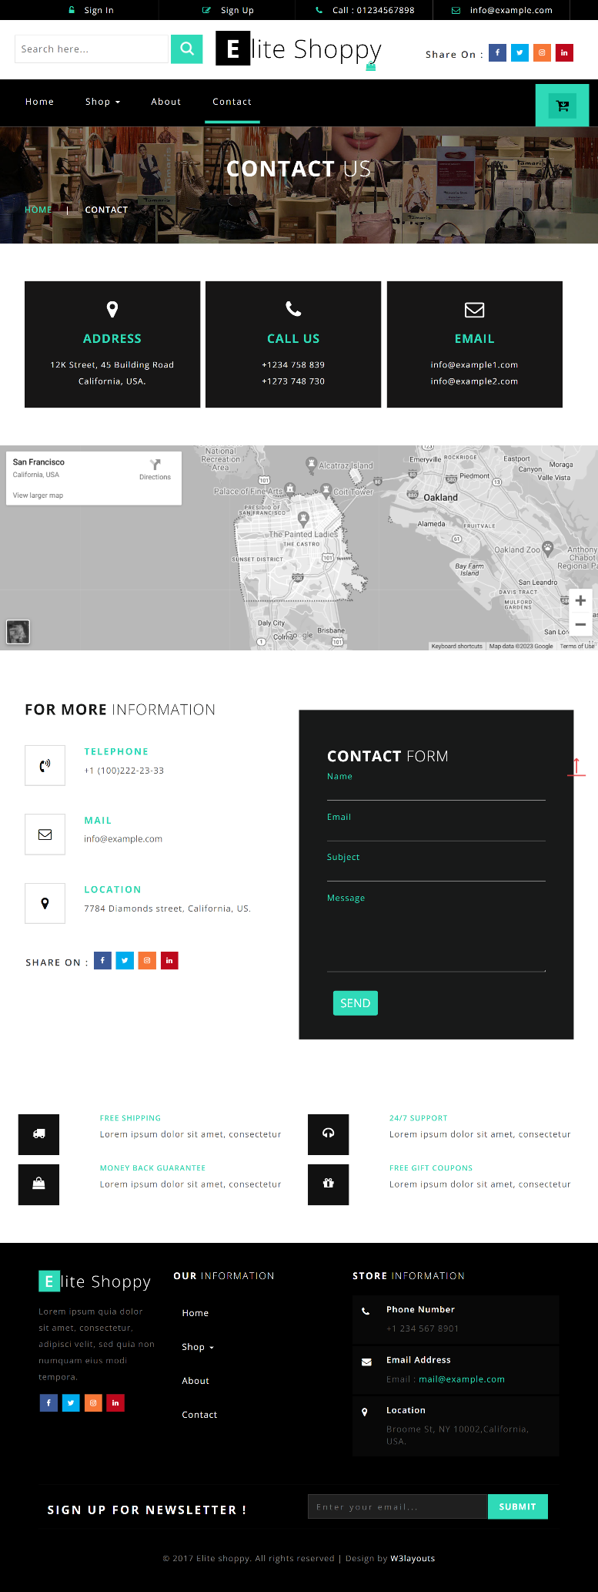

Forma koja se proverava I na klijentu I na serveru I salje poruku na mail

### INDEX.PHP?page=profile

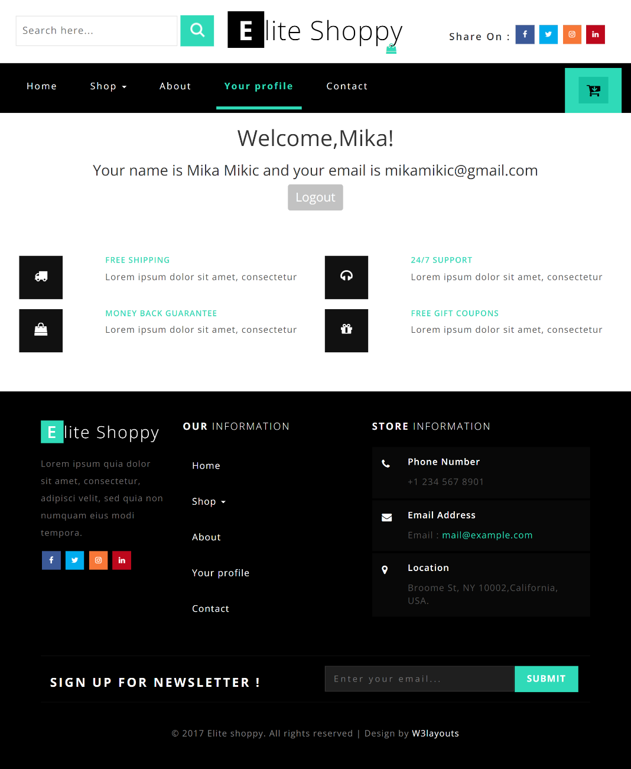

Prikaz korisnickih informacija I Logout opcija

### INDEX.PHP?page=admin_panel

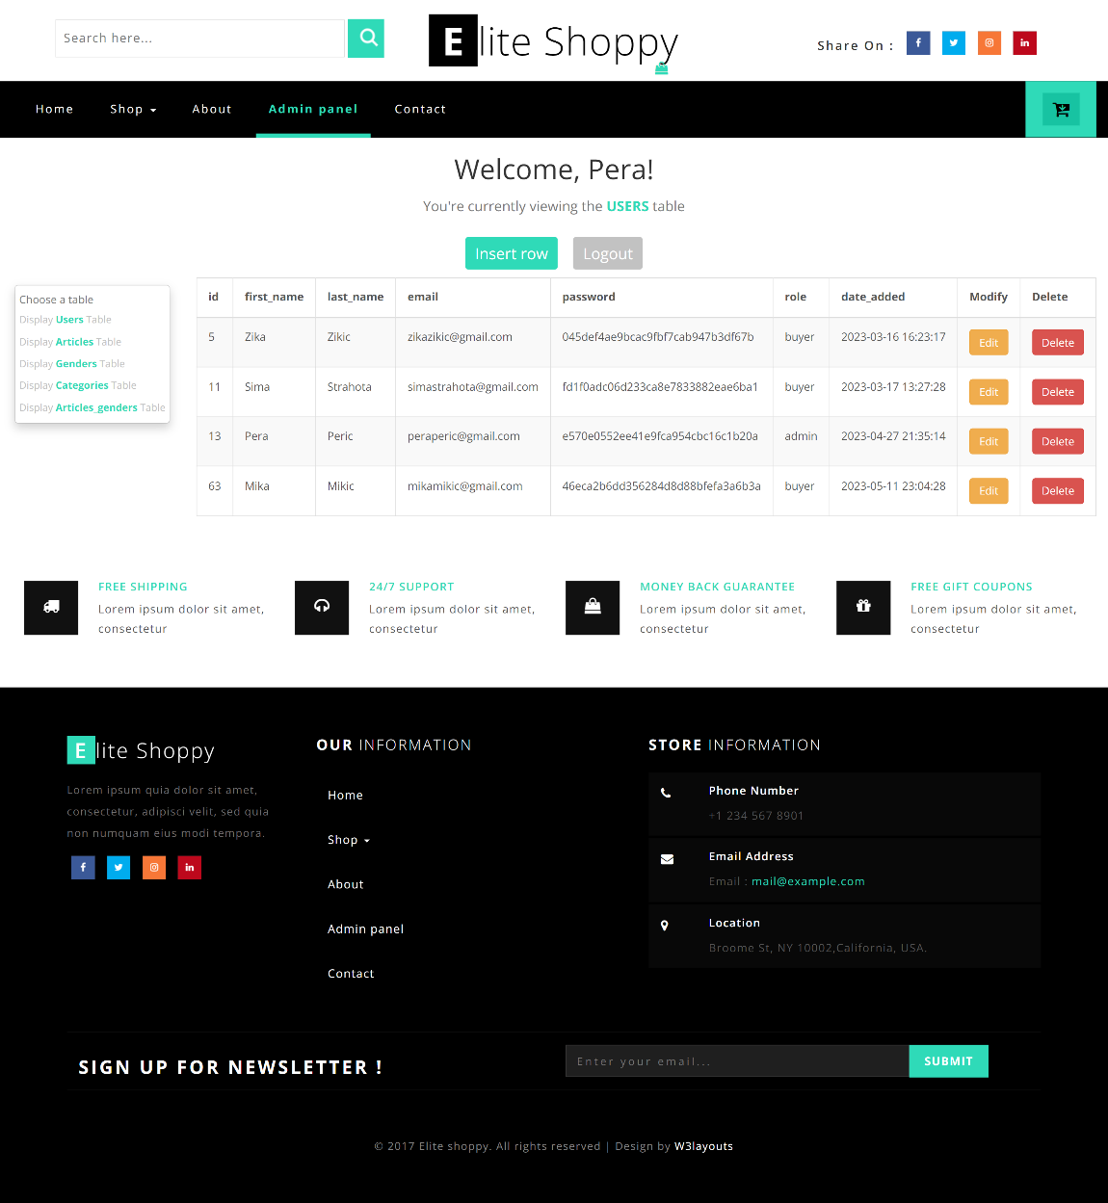

Prikaz i mogucnost brisanja zapisa iz tabele, kao i menjanja postojecih zapisa

Opcije za logout I dodavanje novog zapisa

Sidebar sa izborom svih esencijalnih tabela

### INDEX.PHP?page= insert-articles_genders

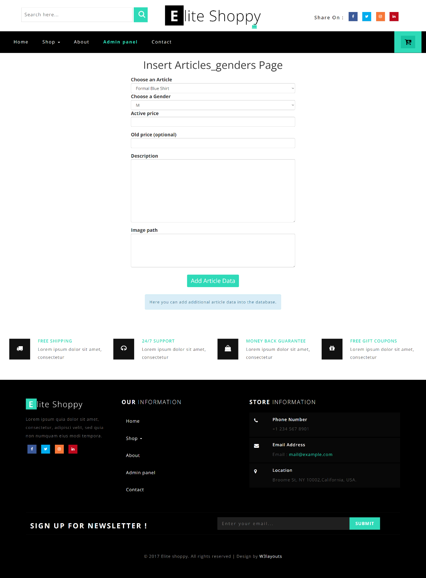

Primer stranice za unos novih zapisa

### INDEX.PHP?page= edit-articles&id=3

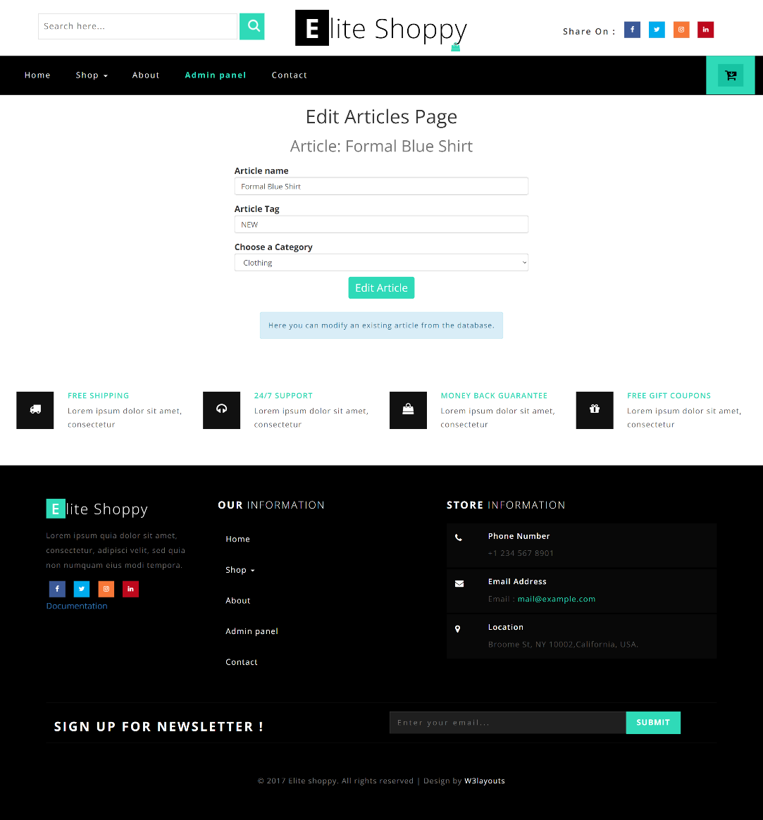

Primer stranice za menjanje postojecih zapisa u bazi

## Kodovi:

### PHP

#### Index.php

<?php  
 session_start();  
 include "config/conn.php";  
 include "models/utility.php";  
  
 include_once "views/fixed/head.php";  
 include_once "views/fixed/header.php";  
  
 #RUTIRANJE  
 isset($_GET['page']) ? $page = $_GET['page'] : $page = "";  
 if ($page){  
 if ($page=="profile") {  
 if (isset($_SESSION['user']) && $_SESSION['user']->role!="admin"){//admin doesn't have a profile page  
 include_once "views/pages/${page}.php";  
 }  
 else {  
 include_once "views/pages/home.php";  
 }  
 }  
 else if ($page=="admin_panel" || $page=="insert-articles" || $page=="insert-users" || $page=="insert-categories" ||  
 $page=="insert-articles_genders" || $page=="edit-users" || $page=="edit-articles" || $page=="edit-categories" || $page=="edit-articles_genders"){  
 if (isset($_SESSION['user']) && $_SESSION['user']->role=="admin") {  
 include_once "views/pages/${page}.php";  
 }  
 else {  
// redirect("https://www.youtube.com/watch?v=E8nOJ4LGhIM");  
 include_once "views/pages/home.php";  
 }  
 }  
 else {  
 include_once "views/pages/${page}.php";  
 }  
 }  
 else {  
 include_once "views/pages/home.php";  
 }  
  
 include_once "views/fixed/footer.php";  
?>

#### Views/pages/edit-articles.php

<?php  
isset($_GET['page']) ? $page = $_GET['page'] : $page = "";  
isset($_GET['id']) ? $id = $_GET['id'] : $id = "";  
  
$words = explode("-",$page);  
$article = findRecord($words[1], $id);  
  
$categories = getAll("categories");  
?>  
<div class="container">  
 <div class="row">  
 <div class="col-12">  
 <h1 class="text-capitalize text-center mb-h1"><?=$words[0] . " " . $words[1]?> page</h1>  
 <h2 class="text-capitalize text-center mb-h1 text-muted">Article: <?=$article->name?></h2>  
 </div>  
 </div>  
</div>  
<div class="container">  
 <div class="row mb-d-flex-center">  
 <div class="col-xs-12 col-sm-6">  
 <form>  
 <div class="form-group">  
 <label for="article-name">Article name</label>  
 <input type="text" class="form-control" id="article-name" name="article-name" value="<?= $article->name?>" placeholder="Example: Running shoes..."/>  
 </div>  
 <div class="form-group">  
 <label for="article-tag">Article Tag</label>  
 <input type="text" class="form-control" id="article-tag" name="article-tag" value="<?= $article->tag?>" placeholder="Example: New..."/>  
 </div>  
 <div class="form-check">  
 <label for="article-name">Choose a Category</label>  
 <select class="form-control" name="article-category-select" id="article-category-select">  
 <?php  
 foreach ($categories as $category) :  
 ?>  
 <option value="<?= $category->id?>" <?= $article->IDcat == $category->id ? "selected='selected'" : ""?>><?= $category->name ?></option>  
 <?php endforeach;?>  
 </select>  
 </div>  
 <div class="form-group mb-d-flex-center">  
 <input type="submit" class="btn mb-btn-action" value="Edit Article" name="btn-edit" id="btn-edit"/>  
 </div>  
 <div class="form-group mb-d-flex-center">  
 <p class="alert alert-info text-center" id="mb-edit-info">Here you can modify an existing article from the database.</p>  
 </div>  
 </form>  
 </div>  
 </div>  
</div>

#### Views/pages/edit-articles_genders.php

<?php  
isset($_GET['page']) ? $page = $_GET['page'] : $page = "";  
isset($_GET['id']) ? $id = $_GET['id'] : $id = "";  
  
$words = explode("-",$page);  
$article_gender = findRecord($words[1], $id);  
  
$categories = getAll("categories");  
$articles = getAll("articles");  
$genders = getAll("genders");  
?>  
<div class="container">  
 <div class="row">  
 <div class="col-12">  
 <h1 class="text-capitalize text-center mb-h1"><?=$words[0] . " " . $words[1]?> page</h1>  
 <h2 class="text-capitalize text-center mb-h1 text-muted">Additional info for article:  
 <?php  
 foreach ($articles as $article) :  
 ?>  
 <?= $article->id == $article_gender->IDarticle ? $article->name : ""?>  
 <?php endforeach;?>  
 </h2>  
 </div>  
 </div>  
</div>  
<div class="container">  
 <div class="row mb-d-flex-center">  
 <div class="col-xs-12 col-sm-6">  
 <form>  
 <div class="form-check">  
 <label for="ag-article">Choose an Article</label>  
 <select class="form-control" name="ag-article" id="ag-article">  
 <?php  
 foreach ($articles as $article) :  
 ?>  
 <option value="<?= $article->id?>" <?= $article->id == $article_gender->IDarticle ? "selected='selected'" : ""?>><?= $article->name ?></option>  
 <?php endforeach;?>  
 </select>  
 </div>  
 <div class="form-check">  
 <label for="ag-gender">Choose a Gender</label>  
 <select class="form-control" name="ag-gender" id="ag-gender">  
 <?php  
 foreach ($genders as $gender) :  
 ?>  
 <option value="<?= $gender->id?>" <?= $gender->id == $article_gender->IDgender ? "selected='selected'" : ""?>><?= $gender->name ?></option>  
 <?php endforeach;?>  
 </select>  
 </div>  
 <div class="form-group">  
 <label for="ag-new-price">Active price</label>  
 <input type="number" class="form-control" min="0" id="ag-new-price" name="ag-new-price" value="<?= $article_gender->priceNew?>"/>  
 </div>  
 <div class="form-group">  
 <label for="ag-old-price">Old price (optional)</label>  
 <input type="number" class="form-control" min="0" id="ag-old-price" name="ag-old-price" value="<?= $article_gender->priceOld?>"/>  
 </div>  
 <div class="form-group">  
 <label for="ag-desc">Description</label>  
 <textarea class="form-control" name="ag-desc" id="ag-desc" cols="30" rows="10"><?= $article_gender->description ?></textarea>  
 </div>  
 <div class="form-group">  
 <label for="ag-img">Image path</label>  
 <textarea class="form-control" name="ag-img" id="ag-img" cols="30" rows="5"><?= $article_gender->image?></textarea>  
 </div>  
 <div class="form-group mb-d-flex-center">  
 <input type="submit" class="btn mb-btn-action" value="Edit Article Data" name="btn-edit" id="btn-edit"/>  
 </div>  
 <div class="form-group mb-d-flex-center">  
 <p class="alert alert-info text-center" id="mb-edit-info">Here you can modify additional article data from the database.</p>  
 </div>  
 </form>  
 </div>  
 </div>  
</div>

#### Views/pages/edit-categories.php

<?php  
isset($_GET['page']) ? $page = $_GET['page'] : $page = "";  
isset($_GET['id']) ? $id = $_GET['id'] : $id = "";  
  
$words = explode("-",$page);  
$category = findRecord($words[1], $id);  
?>  
<div class="container">  
 <div class="row">  
 <div class="col-12">  
 <h1 class="text-capitalize text-center mb-h1"><?=$words[0] . " " . $words[1]?> page</h1>  
 <h2 class="text-capitalize text-center mb-h1 text-muted">Category: <?=$category->name?></h2>  
 </div>  
 </div>  
</div>  
<div class="container">  
 <div class="row mb-d-flex-center">  
 <div class="col-xs-12 col-sm-6">  
 <form>  
 <div class="form-group">  
 <label for="category-name">Category name</label>  
 <input type="text" class="form-control" id="category-name" name="category-name" value="<?= $category->name?>"/>  
 </div>  
 <div class="form-group mb-d-flex-center">  
 <input type="submit" class="btn mb-btn-action" value="Edit Category" name="btn-edit" id="btn-edit"/>  
 </div>  
 <div class="form-group mb-d-flex-center">  
 <p class="alert alert-info text-center" id="mb-edit-info">Here you can modify an existing category from the database.</p>  
 </div>  
 </form>  
 </div>  
 </div>  
</div>

#### Views/pages/edit-users.php

<?php  
isset($_GET['page']) ? $page = $_GET['page'] : $page = "";  
isset($_GET['id']) ? $id = $_GET['id'] : $id = "";  
  
$words = explode("-",$page);  
$user = findRecord($words[1], $id);  
?>  
<div class="container">  
 <div class="row">  
 <div class="col-12">  
 <h1 class="text-capitalize text-center mb-h1"><?=$words[0] . " " . $words[1]?> page</h1>  
 <h2 class="text-capitalize text-center mb-h1 text-muted">User: <?=$user->first_name . " " . $user->last_name?></h2>  
 </div>  
 </div>  
</div>  
<div class="container">  
 <div class="row mb-d-flex-center">  
 <div class="col-xs-12 col-sm-6">  
 <form>  
 <div class="form-group">  
 <label for="first-name">First Name</label>  
 <input type="text" class="form-control" id="user-first-name" name="first-name" value="<?= $user->first_name ?>" placeholder="Example: Mika"/>  
 </div>  
 <div class="form-group">  
 <label for="last-name">Last Name</label>  
 <input type="text" class="form-control" id="user-last-name" name="last-name" value="<?= $user->last_name ?>" placeholder="Example: Mikic"/>  
 </div>  
 <div class="form-group">  
 <label for="email">Email</label>  
 <input type="email" class="form-control" id="user-email" name="email" value="<?= $user->email ?>" placeholder="Example: example@gmail.com"/>  
 </div>  
 <div class="form-group">  
 <label for="password">Password</label>  
 <input type="password" class="form-control" name="password" id="user-password"/>  
 </div>  
 <div class="form-group">  
 <label for="password">Confirm Password</label>  
 <input type="password" class="form-control" name="passwordConfirm" id="user-passwordConfirm"/>  
 </div>  
 <div class="form-group mb-d-flex-center">  
 <input type="submit" class="btn mb-btn-action" value="Edit User" name="btn-edit" id="btn-edit"/>  
 </div>  
 <div class="form-group mb-d-flex-center">  
 <p class="alert alert-info text-center" id="mb-edit-info">Here you can modify an existing user from the database.</p>  
 </div>  
 </form>  
 </div>  
 </div>  
</div>

#### Models/get-articles.php

<?php  
session_start();  
include "utility.php";  
include "../config/conn.php";  
include "functions.php";  
  
if ($_SERVER['REQUEST_METHOD'] == 'GET') {  
 $inputSearch = isset($_GET['inputSearch']) ? $_GET['inputSearch'] : '';  
 $inputPrice = isset($_GET['inputPrice']) ? $_GET['inputPrice'] : '';  
 $inputSort = isset($_GET['inputSort']) ? $_GET['inputSort'] : '1';  
 $inputCategory = isset($_GET['inputCategory']) ? $_GET['inputCategory'] : '';  
 $inputGender = isset($_GET['inputGender']) ? $_GET['inputGender'] : '';  
  
 $errors = [];  
// ag.id  
 $sql = "SELECT a.id, a.name AS 'article_name', a.IDcat, a.tag, g.id AS 'IDgender', g.name AS 'gender', CONCAT('$', ag.priceNew) AS 'active_price',  
 CONCAT('$', ag.priceOld) AS 'old_price', ag.description, ag.image  
 FROM articles_genders ag  
 JOIN articles a ON ag.IDarticle = a.id  
 JOIN genders g ON ag.IDgender = g.id  
 WHERE 1=1";  
  
 $params = [];  
  
 if (!empty($inputSearch)) {  
 $sql .= " AND a.name LIKE :inputSearch";  
 $params[':inputSearch'] = '%' . $inputSearch . '%';  
 }  
  
 if (!empty($inputGender)) {  
 $sql .= " AND g.id = :inputGender";  
 $params[':inputGender'] = $inputGender;  
 }  
  
 if (!empty($inputCategory)) {  
 $sql .= " AND a.IDcat = :inputCategory";  
 $params[':inputCategory'] = $inputCategory;  
 }  
  
 if (!empty($inputPrice)) {  
 $sql .= " AND ag.priceNew <= :inputPrice";  
 $params[':inputPrice'] = $inputPrice;  
 }  
  
 if ($inputSort === '1') {  
 $sql .= " ORDER BY a.name ASC";  
 }  
 else if ($inputSort === '2') {  
 $sql .= " ORDER BY a.name DESC";  
 }  
 else if ($inputSort === '3') {  
 $sql .= " ORDER BY ag.priceNew DESC";  
 }  
 else {  
 $sql .= " ORDER BY ag.priceNew ASC";  
 }  
  
 $query = $conn->prepare($sql);  
  
 foreach ($params as $param=>&$value) {//&  
 $query->bindParam($param,$value);  
 }  
  
 $query->execute();  
  
 if ($query->rowCount() > 0) {  
 $result = $query->fetchAll();  
 http_response_code(202);  
 echo json_encode($result);  
 } else {  
 $errors[] = "Nijedan artikal nije pronadjen.";  
 $result = ["message" => "Ima grešaka.",  
 "errors" => $errors];  
 http_response_code(404);  
 echo json_encode($result);  
 }  
}  
else {  
 redirect("../index.php?page=about");  
}  
?>

#### Models/edit-articles.php

<?php  
session_start();  
include "utility.php";  
include "../config/conn.php";  
include "functions.php";  
  
#URL PROTECTION  
if (!isset($_SESSION['user']) || $_SESSION['user']->role != "admin") {  
 redirect("../index.php?page=profile");  
}  
  
header("Content-type: application/json");  
if ($_SERVER['REQUEST_METHOD'] == 'POST') {  
 $id = $_POST['id'];  
 $name = $_POST['name'];  
 $tag = $_POST['tag'];  
 $IDcat = $_POST['IDcat'];  
  
 $errors = [];  
  
 if (empty($name)){  
 $errors[] = "Naziv ne sme biti prazan!";  
 }  
 if (empty($tag)){  
 $tag = NULL;  
 }  
  
 if ($conn) {  
 if(count($errors) > 0){  
 http_response_code(401);//unauthorized  
 $result = ["message" => "Ima grešaka u unosu podataka.",  
 "errors" => $errors];  
 echo json_encode($result);  
 die;  
 }  
 else {  
 $sql = "UPDATE articles SET name = :name, tag = :tag, IDcat = :IDcat  
 WHERE id = :id;";  
  
 $query = $conn->prepare($sql);  
 $query->bindParam(":id", $id);  
 $query->bindParam(":name", $name);  
 $query->bindParam(":tag",$tag);  
 $query->bindParam(":IDcat",$IDcat);  
  
 $result = $query->execute();  
  
 http_response_code(200);  
 $result = ["message" => "Uspešna promena u bazi."];  
 echo json_encode($result);  
 }  
 }  
 else {  
 echo $result = ["message" => "Nema konekcije sa bazom."];  
 }  
}else {  
 redirect("../index.php?page=about");  
}  
?>

#### Models/edit-articles_genders.php

<?php  
  
  
session_start();  
include "utility.php";  
include "../config/conn.php";  
include "functions.php";  
  
if (!isset($_SESSION['user']) || $_SESSION['user']->role != "admin") {  
 redirect("../index.php?page=profile");  
}  
  
if ($_SERVER['REQUEST_METHOD'] == 'POST') {  
 $id = $_POST['id'];  
 $IDarticle = $_POST['IDarticle'];  
 $IDgender = $_POST['IDgender'];  
 $priceNew = $_POST['priceNew'];  
 $priceOld = $_POST['priceOld'];  
 $description = $_POST['description'];  
 $image = $_POST['image'];  
  
 $errors = [];  
 #PROVERA  
 if (empty($priceNew) || $priceNew <= 0 || $priceOld <= 0) {  
 $errors[] = "Cena mora biti pozitivan broj!";  
 }  
 if (empty($priceOld)) {  
 $priceOld = NULL;  
 }  
 if (empty($description)) {  
 $errors[] = "Opis artikla mora postojati!";  
 }  
 if (empty($image)) {  
 $errors[] = "Putanja do slike artikla mora postojati!";  
 }  
  
 if (count($errors) == 0) {  
 if ($conn) {  
 $sql = "UPDATE articles_genders   
 SET IDarticle = :IDarticle, IDgender = :IDgender, priceNew = :priceNew,  
 priceOld = :priceOld, description = :description, image = :image  
 WHERE id = :id;";  
  
 $query = $conn->prepare($sql);  
  
 $query->bindParam(":id", $id);  
 $query->bindParam(":IDarticle", $IDarticle);  
 $query->bindParam(":IDgender", $IDgender);  
 $query->bindParam(":priceNew", $priceNew);  
 $query->bindParam(":priceOld", $priceOld);  
 $query->bindParam(":description", $description);  
 $query->bindParam(":image", $image);  
  
 $result = $query->execute();  
  
 if ($result) {  
 $result = ["message" => "Dodatne informacije o artiklu su uspešno izmenjene u bazi."];  
 $status = 201;//Created  
 } else {  
 $errors[] = "Greška prilikom unosa (Kombinacija izabranih vrednosti za artikal i pol možda već postoji).";  
 $result = ["errors" => $errors];  
 $status = 500;//Internal server error  
 }  
  
 http_response_code($status);  
 echo json_encode($result);  
 } else {  
 echo $result = ["message" => "Nema konekcije sa bazom."];  
 }  
 } else {  
 $result = ["errors" => $errors];  
 http_response_code(406);//Not acceptable  
 echo json_encode($result);  
 }  
} else {  
 redirect("../index.php?page=about");  
}  
?>

#### Models/edit-categories.php

<?php  
session_start();  
include "utility.php";  
include "../config/conn.php";  
include "functions.php";  
  
#URL PROTECTION  
if (!isset($_SESSION['user']) || $_SESSION['user']->role != "admin") {  
 redirect("../index.php?page=profile");  
}  
  
header("Content-type: application/json");  
if ($_SERVER['REQUEST_METHOD'] == 'POST') {  
 $id = $_POST['id'];  
 $name = $_POST['name'];  
  
 $errors = [];  
  
 if (empty($name)){  
 $errors[] = "Naziv ne sme biti prazan!";  
 }  
  
 if ($conn) {  
 if(count($errors) > 0){  
 http_response_code(401);//unauthorized  
 $result = ["message" => "Ima grešaka u unosu podataka.",  
 "errors" => $errors];  
 echo json_encode($result);  
 die;  
 }  
 else {  
 $sql = "UPDATE categories SET name = :name  
 WHERE id = :id;";  
  
 $query = $conn->prepare($sql);  
 $query->bindParam(":id", $id);  
 $query->bindParam(":name", $name);  
  
 $result = $query->execute();  
  
 http_response_code(200);  
 $result = ["message" => "Uspešna promena u bazi."];  
 echo json_encode($result);  
 }  
 }  
 else {  
 echo $result = ["message" => "Nema konekcije sa bazom."];  
 }  
}else {  
 redirect("../index.php?page=about");  
}  
?>

#### Models/edit-users.php

<?php  
session_start();  
include "utility.php";  
include "../config/conn.php";  
include "functions.php";  
  
#URL PROTECTION  
if (!isset($_SESSION['user']) || $_SESSION['user']->role != "admin") {  
 redirect("../index.php?page=profile");  
}  
  
header("Content-type: application/json");  
if ($_SERVER['REQUEST_METHOD'] == 'POST') {  
 $id = $_POST['id'];  
 $firstName = $_POST['firstName'];  
 $lastName = $_POST['lastName'];  
 $email = $_POST['email'];  
 $password = $_POST['password'];  
 $confirmPass = $_POST['passwordConfirm'];  
  
  
 if ($conn) {  
 $errors = registerInputsCheck($firstName, $lastName, $email, $password, $confirmPass);  
  
 if(count($errors) > 0){  
 http_response_code(401);//unauthorized  
 $result = ["message" => "Ima grešaka u unosu podataka.",  
 "errors" => $errors];  
 echo json_encode($result);  
 die;  
 }  
 else {  
 $hashPassword = md5($password . "conststring");  
 //upit za bazu  
 $query = $conn->prepare("UPDATE users  
 SET first_name = :first_name,last_name = :last_name,email = :email,password = :hashPassword  
 WHERE id = :id");  
  
 //parameters  
 $query->bindParam(':id', $id);  
 $query->bindParam(':first_name', $firstName);  
 $query->bindParam(':last_name', $lastName);  
 $query->bindParam(':email', $email);  
 $query->bindParam(':hashPassword', $hashPassword);  
  
 $result = $query->execute();  
  
 http_response_code(200);  
 $result = ["message" => "Uspešna promena u bazi."];  
 echo json_encode($result);  
 }  
 }  
 else {  
 echo $result = ["message" => "Nema konekcije sa bazom."];  
 }  
}else {  
 redirect("../index.php?page=about");  
}  
?>

#### Views/fixed/head.php

<!DOCTYPE html>  
<html>  
<head>  
 <title>Elite Shoppy - An Ecommerce Online Shopping Website</title>  
 <!--/tags -->  
 <meta name="viewport" content="width=device-width, initial-scale=1"/>  
 <meta http-equiv="Content-Type" content="text/html; charset=utf-8" />  
 <meta name="keywords" content="Elite Shoppy Responsive web template, Bootstrap Web Templates, Flat Web Templates, Android Compatible web template,  
Smartphone Compatible web template, free webdesigns for Nokia, Samsung, LG, SonyEricsson, Motorola web design" />  
 <script type="application/x-javascript"> addEventListener("load", function() { setTimeout(hideURLbar, 0); }, false);  
 function hideURLbar(){ window.scrollTo(0,1); } </script>  
 <!--//tags -->  
 <link href="css/bootstrap.css" rel="stylesheet" type="text/css" media="all" />  
<!-- <link href="https://cdn.jsdelivr.net/npm/bootstrap@5.0.2/dist/css/bootstrap.min.css" rel="stylesheet" integrity="sha384-EVSTQN3/azprG1Anm3QDgpJLIm9Nao0Yz1ztcQTwFspd3yD65VohhpuuCOmLASjC" crossorigin="anonymous">-->  
 <link rel="stylesheet" type="text/css" href="css/jquery-ui.css"/>  
 <link href="css/style.css" rel="stylesheet" type="text/css" media="all" />  
 <link href="css/font-awesome.css" rel="stylesheet"/>  
 <!-- //for bootstrap working -->  
 <link href="//fonts.googleapis.com/css?family=Open+Sans:300,300i,400,400i,600,600i,700,700i,800" rel="stylesheet"/>  
 <link href='//fonts.googleapis.com/css?family=Lato:400,100,100italic,300,300italic,400italic,700,900,900italic,700italic' rel='stylesheet' type='text/css'/>  
</head>  
<body>  
<!--  
Author: W3layouts  
Author URL: http://w3layouts.com  
License: Creative Commons Attribution 3.0 Unported  
License URL: http://creativecommons.org/licenses/by/3.0/  
-->

#### Views/fixed/header.php

<?php  
 if (!isset($_SESSION['user'])):  
?>  
<!-- header -->  
<div class="header" id="home">  
 <div class="container">  
 <ul>  
 <li> <a href="#" data-toggle="modal" data-target="#myModal"><i class="fa fa-unlock-alt" aria-hidden="true"></i> Sign In </a></li>  
 <li> <a href="#" data-toggle="modal" data-target="#myModal2"><i class="fa fa-pencil-square-o" aria-hidden="true"></i> Sign Up </a></li>  
 <li><i class="fa fa-phone" aria-hidden="true"></i> Call : 01234567898</li>  
 <li><i class="fa fa-envelope-o" aria-hidden="true"></i> <a href="mailto:info@example.com">info@example.com</a></li>  
 </ul>  
 </div>  
</div>  
<!-- //header -->  
 <?php endif;?>  
<!-- header-bot -->  
<div class="header-bot">  
 <div class="header-bot_inner_wthreeinfo_header_mid">  
 <div class="col-md-4 header-middle">  
 <form action="#" method="post">  
 <input type="search" name="search" placeholder="Search here..." required="">  
 <input type="submit" value=" ">  
 <div class="clearfix"></div>  
 </form>  
 </div>  
 <!-- header-bot -->  
 <div class="col-md-4 logo_agile">  
 <h1><a href="index.html"><span>E</span>lite Shoppy <i class="fa fa-shopping-bag top_logo_agile_bag" aria-hidden="true"></i></a></h1>  
 </div>  
 <!-- header-bot -->  
 <div class="col-md-4 agileits-social top_content">  
 <ul class="social-nav model-3d-0 footer-social w3_agile_social">  
 <li class="share">Share On : </li>  
 <li><a href="#" class="facebook">  
 <div class="front"><i class="fa fa-facebook" aria-hidden="true"></i></div>  
 <div class="back"><i class="fa fa-facebook" aria-hidden="true"></i></div></a></li>  
 <li><a href="#" class="twitter">  
 <div class="front"><i class="fa fa-twitter" aria-hidden="true"></i></div>  
 <div class="back"><i class="fa fa-twitter" aria-hidden="true"></i></div></a></li>  
 <li><a href="#" class="instagram">  
 <div class="front"><i class="fa fa-instagram" aria-hidden="true"></i></div>  
 <div class="back"><i class="fa fa-instagram" aria-hidden="true"></i></div></a></li>  
 <li><a href="#" class="pinterest">  
 <div class="front"><i class="fa fa-linkedin" aria-hidden="true"></i></div>  
 <div class="back"><i class="fa fa-linkedin" aria-hidden="true"></i></div></a></li>  
 </ul>  
  
  
  
 </div>  
 <div class="clearfix"></div>  
 </div>  
</div>  
<!-- //header-bot -->  
<?php include_once "views/fixed/navigation.php";?>

#### Views/fixed/navigation.php

<?php  
 include "models/functions.php";  
 isset($_GET['page']) ? $page = $_GET['page'] : $page = "";  
  
 #GET NAVIGATION  
 $navNames = [];  
 $navLinks = [];  
 $arrNav = printNavigation();  
 if (!isset($_SESSION['user'])){  
 foreach ($arrNav as $obj) {  
 if ($obj->text != 'Admin panel' && $obj->text != 'Your profile') {  
 $navNames[] = $obj->text;  
 $navLinks[] = $obj->page;  
 }  
 }  
 }  
  
 if (isset($_SESSION['user']) && $_SESSION['user']->role != "admin") {// || (!isset($_SESSION['user']))  
 foreach ($arrNav as $obj) {  
 if ($obj->text != 'Admin panel') {  
 $navNames[] = $obj->text;  
 $navLinks[] = $obj->page;  
 }  
 }  
 }  
  
 if (isset($_SESSION['user']) && $_SESSION['user']->role == "admin") {  
 foreach ($arrNav as $obj) {  
 if ($obj->text != 'Your profile'){  
 $navNames[] = $obj->text;  
 $navLinks[] = $obj->page;  
 }  
 }  
 }  
?>  
<!-- banner -->  
<div class="ban-top">  
 <div class="container-fluid">  
 <div class="top_nav_left">  
 <nav class="navbar navbar-default">  
 <div class="container-fluid">  
 <!-- Brand and toggle get grouped for better mobile display -->  
 <div class="navbar-header">  
 <button type="button" class="navbar-toggle collapsed" data-toggle="collapse" data-target="#bs-example-navbar-collapse-1" aria-expanded="false">  
 <span class="sr-only">Toggle navigation</span>  
 <span class="icon-bar"></span>  
 <span class="icon-bar"></span>  
 <span class="icon-bar"></span>  
 </button>  
 </div>  
 <!-- Collect the nav links, forms, and other content for toggling -->  
 <div class="collapse navbar-collapse menu--shylock" id="bs-example-navbar-collapse-1">  
 <ul class="nav navbar-nav menu__list">  
 <?php  
 $br = 0;  
 foreach ($navNames as $name){  
 if ($br == 0) {  
 ?>  
 <li class=" menu__item <?= $page ? '' : 'menu__item--current'?>"><a class="menu__link" href="index.php"><?= $name ?> <span class="sr-only">(current)</span></a></li>  
 <?php }  
 else if ($br == 1) {  
 ?>  
 <li class="dropdown menu__item <?= $page && $page == $navLinks[$br] ? 'menu__item--current' : ''?>">  
 <a href="#" class="dropdown-toggle menu__link" data-toggle="dropdown" role="button" aria-haspopup="true" aria-expanded="false"><?= $name ?> <span class="caret"></span></a>  
 <ul class="dropdown-menu p-5">  
 <div class="agile_inner_drop_nav_info">  
 <div class="col-sm-3">  
 <ul class="multi-column-dropdown">  
 <!--ADD CATEGORIES FROM DATABASE!-->  
 <li><a href="index.php?page=<?= $navLinks[$br] ?>&category=clothing">Clothing</a></li>  
 <li><a href="index.php?page=<?= $navLinks[$br] ?>&category=watches">Watches</a></li>  
 <li><a href="index.php?page=<?= $navLinks[$br] ?>&category=footwear">Footwear</a></li>  
 <li><a href="index.php?page=<?= $navLinks[$br] ?>&category=bags">Bags</a></li>  
 </ul>  
 </div>  
 <div class="clearfix"></div>  
 </div>  
 </ul>  
 </li>  
 <?php }  
 else {  
 ?>  
 <li class=" menu__item <?= $page && $page == $navLinks[$br] ? 'menu__item--current' : ''?>"><a class="menu__link <?= $navLinks[$br] == "admin_panel" || $navLinks[$br] == "profile" ? "mb-special-link" : ""?>" href="index.php?page=<?=$navLinks[$br]?>"><?= $name?></a></li>  
 <?php }$br++;}?>  
 </ul>  
 </div>  
 </div>  
 </nav>  
 </div>  
 <div class="top_nav_right">  
 <div class="wthreecartaits wthreecartaits2 cart cart box_1">  
 <form action="#" method="post" class="last">  
 <input type="hidden" name="cmd" value="_cart">  
 <input type="hidden" name="display" value="1">  
 <button class="w3view-cart" type="submit" name="submit" value=""><i class="fa fa-cart-arrow-down" aria-hidden="true"></i></button>  
 </form>  
 </div>  
 </div>  
 <div class="clearfix"></div>  
 </div>  
</div>  
<!-- //banner-top -->  
<!-- Modal1 - SIGN IN -->  
<div class="modal fade" id="myModal" tabindex="-1" role="dialog">  
 <div class="modal-dialog">  
 <!-- Modal content-->  
 <div class="modal-content">  
 <div class="modal-header">  
 <button type="button" class="close" data-dismiss="modal">&times;</button>  
 </div>  
 <div class="modal-body modal-body-sub_agile">  
 <div class="col-md-8 modal_body_left modal_body_left1">  
 <h3 class="agileinfo_sign">Sign In <span>Now</span></h3>  
 <form id="mb-form-login">  
 <div class="styled-input agile-styled-input-top">  
 <input type="email" name="login-email" id="login-email"/>  
 <label>Email</label>  
 <span></span>  
 </div>  
 <div class="styled-input">  
 <input type="password" name="login-password" id="login-password"/>  
 <label>Password</label>  
 <span></span>  
 </div>  
 <input type="submit" name="btn-login" id="mb-btn-submit-login" value="Sign In"/>  
 <p class="alert alert-danger mb-d-none" id="mb-login-message"></p>  
 </form>  
 <ul class="social-nav model-3d-0 footer-social w3_agile_social top_agile_third">  
 <li><a href="#" class="facebook">  
 <div class="front"><i class="fa fa-facebook" aria-hidden="true"></i></div>  
 <div class="back"><i class="fa fa-facebook" aria-hidden="true"></i></div></a></li>  
 <li><a href="#" class="twitter">  
 <div class="front"><i class="fa fa-twitter" aria-hidden="true"></i></div>  
 <div class="back"><i class="fa fa-twitter" aria-hidden="true"></i></div></a></li>  
 <li><a href="#" class="instagram">  
 <div class="front"><i class="fa fa-instagram" aria-hidden="true"></i></div>  
 <div class="back"><i class="fa fa-instagram" aria-hidden="true"></i></div></a></li>  
 <li><a href="#" class="pinterest">  
 <div class="front"><i class="fa fa-linkedin" aria-hidden="true"></i></div>  
 <div class="back"><i class="fa fa-linkedin" aria-hidden="true"></i></div></a></li>  
 </ul>  
 <div class="clearfix"></div>  
 <p><a href="#" data-toggle="modal" data-target="#myModal2" > Don't have an account?</a></p>  
  
 </div>  
 <div class="col-md-4 modal_body_right modal_body_right1">  
 <img src="images/log_pic.jpg" alt=" "/>  
 </div>  
 <div class="clearfix"></div>  
 </div>  
 </div>  
 <!-- //Modal content-->  
 </div>  
</div>  
<!-- //Modal1 -->  
<!-- Modal2 - SIGN UP-->  
<div class="modal fade" id="myModal2" tabindex="-1" role="dialog">  
 <div class="modal-dialog">  
 <!-- Modal content-->  
 <div class="modal-content">  
 <div class="modal-header">  
 <button type="button" class="close" data-dismiss="modal">&times;</button>  
 </div>  
 <div class="modal-body modal-body-sub_agile">  
 <div class="col-md-8 modal_body_left modal_body_left1">  
 <h3 class="agileinfo_sign">Sign Up <span>Now</span></h3>  
 <form id="mb-form-register"> <!--action="models/register.php" method="post"-->  
 <div class="styled-input agile-styled-input-top">  
 <input type="text" name="first-name" id="first-name"/>  
 <label>First name</label>  
 <span></span>  
 </div>  
 <div class="styled-input">  
 <input type="text" name="last-name" id="last-name"/>  
 <label>Last name</label>  
 <span></span>  
 </div>  
 <div class="styled-input">  
 <input type="email" name="email" id="email"/>  
 <label>Email</label>  
 <span></span>  
 </div>  
 <div class="styled-input">  
 <input type="password" name="password" id="password"/>  
 <label>Password</label>  
 <span></span>  
 </div>  
 <div class="styled-input">  
 <input type="password" name="password-confirm" id="password-confirm"/>  
 <label>Confirm password</label>  
 <span></span>  
 </div>  
 <input type="submit" name="btn-register" id="mb-btn-submit-register" value="Sign Up"/>  
 <p class="alert alert-danger mb-d-none" id="mb-register-message"></p>  
 </form>  
 <ul class="social-nav model-3d-0 footer-social w3_agile_social top_agile_third">  
 <li><a href="#" class="facebook">  
 <div class="front"><i class="fa fa-facebook" aria-hidden="true"></i></div>  
 <div class="back"><i class="fa fa-facebook" aria-hidden="true"></i></div></a></li>  
 <li><a href="#" class="twitter">  
 <div class="front"><i class="fa fa-twitter" aria-hidden="true"></i></div>  
 <div class="back"><i class="fa fa-twitter" aria-hidden="true"></i></div></a></li>  
 <li><a href="#" class="instagram">  
 <div class="front"><i class="fa fa-instagram" aria-hidden="true"></i></div>  
 <div class="back"><i class="fa fa-instagram" aria-hidden="true"></i></div></a></li>  
 <li><a href="#" class="pinterest">  
 <div class="front"><i class="fa fa-linkedin" aria-hidden="true"></i></div>  
 <div class="back"><i class="fa fa-linkedin" aria-hidden="true"></i></div></a></li>  
 </ul>  
 <div class="clearfix"></div>  
 <p><a href="#">By clicking register, I agree to your terms</a></p>  
  
 </div>  
 <div class="col-md-4 modal_body_right modal_body_right1">  
 <img src="images/log_pic.jpg" alt=" "/>  
 </div>  
 <div class="clearfix"></div>  
 </div>  
 </div>  
 <!-- //Modal content-->  
 </div>  
</div>  
<!-- //Modal2 -->

#### Views/fixed/footer.php

<!--/grids-->  
<div class="coupons">  
 <div class="coupons-grids text-center">  
 <div class="w3layouts_mail_grid">  
 <div class="col-md-3 w3layouts_mail_grid_left">  
 <div class="w3layouts_mail_grid_left1 hvr-radial-out">  
 <i class="fa fa-truck" aria-hidden="true"></i>  
 </div>  
 <div class="w3layouts_mail_grid_left2">  
 <h3>FREE SHIPPING</h3>  
 <p>Lorem ipsum dolor sit amet, consectetur</p>  
 </div>  
 </div>  
 <div class="col-md-3 w3layouts_mail_grid_left">  
 <div class="w3layouts_mail_grid_left1 hvr-radial-out">  
 <i class="fa fa-headphones" aria-hidden="true"></i>  
 </div>  
 <div class="w3layouts_mail_grid_left2">  
 <h3>24/7 SUPPORT</h3>  
 <p>Lorem ipsum dolor sit amet, consectetur</p>  
 </div>  
 </div>  
 <div class="col-md-3 w3layouts_mail_grid_left">  
 <div class="w3layouts_mail_grid_left1 hvr-radial-out">  
 <i class="fa fa-shopping-bag" aria-hidden="true"></i>  
 </div>  
 <div class="w3layouts_mail_grid_left2">  
 <h3>MONEY BACK GUARANTEE</h3>  
 <p>Lorem ipsum dolor sit amet, consectetur</p>  
 </div>  
 </div>  
 <div class="col-md-3 w3layouts_mail_grid_left">  
 <div class="w3layouts_mail_grid_left1 hvr-radial-out">  
 <i class="fa fa-gift" aria-hidden="true"></i>  
 </div>  
 <div class="w3layouts_mail_grid_left2">  
 <h3>FREE GIFT COUPONS</h3>  
 <p>Lorem ipsum dolor sit amet, consectetur</p>  
 </div>  
 </div>  
 <div class="clearfix"> </div>  
 </div>  
  
 </div>  
</div>  
<!--grids-->  
<!-- footer -->  
<div class="footer">  
 <div class="footer_agile_inner_info_w3l container">  
 <div class="row">  
 <div class="col-md-3 footer-left">  
 <h2><a href="index.php"><span>E</span>lite Shoppy </a></h2>  
 <p>Lorem ipsum quia dolor  
 sit amet, consectetur, adipisci velit, sed quia non  
 numquam eius modi tempora.</p>  
 <ul class="social-nav model-3d-0 footer-social w3_agile_social two">  
 <li><a href="#" class="facebook">  
 <div class="front"><i class="fa fa-facebook" aria-hidden="true"></i></div>  
 <div class="back"><i class="fa fa-facebook" aria-hidden="true"></i></div></a></li>  
 <li><a href="#" class="twitter">  
 <div class="front"><i class="fa fa-twitter" aria-hidden="true"></i></div>  
 <div class="back"><i class="fa fa-twitter" aria-hidden="true"></i></div></a></li>  
 <li><a href="#" class="instagram">  
 <div class="front"><i class="fa fa-instagram" aria-hidden="true"></i></div>  
 <div class="back"><i class="fa fa-instagram" aria-hidden="true"></i></div></a></li>  
 <li><a href="#" class="pinterest">  
 <div class="front"><i class="fa fa-linkedin" aria-hidden="true"></i></div>  
 <div class="back"><i class="fa fa-linkedin" aria-hidden="true"></i></div></a></li>  
 </ul>  
 </div>  
 <div class="col-md-4 sign-gd">  
 <h4>Our <span>Information</span> </h4>  
 <ul>  
 <?php  
 $br = 0;  
 foreach ($navNames as $name){  
 if ($br == 0) {  
 ?>  
 <li class=" menu__item <?= $page ? '' : 'menu__item--current'?>"><a class="menu__link" href="index.php"><?= $name ?> <span class="sr-only">(current)</span></a></li>  
 <?php }  
 else if ($br == 1) {  
 ?>  
 <li class="dropdown menu__item <?= $page && $page == $navLinks[$br] ? 'menu__item--current' : ''?>">  
 <a href="#" class="dropdown-toggle menu__link" data-toggle="dropdown" role="button" aria-haspopup="true" aria-expanded="false"><?= $name ?> <span class="caret"></span></a>  
 <ul class="dropdown-menu p-5">  
 <div class="agile_inner_drop_nav_info">  
 <div class="col-sm-3">  
 <ul class="multi-column-dropdown">  
 <!--ADD CATEGORIES FROM DATABASE!-->  
 <li><a href="index.php?page=<?= $navLinks[$br] ?>&category=clothing">Clothing</a></li>  
 <li><a href="index.php?page=<?= $navLinks[$br] ?>&category=watches">Watches</a></li>  
 <li><a href="index.php?page=<?= $navLinks[$br] ?>&category=footwear">Footwear</a></li>  
 <li><a href="index.php?page=<?= $navLinks[$br] ?>&category=bags">Bags</a></li>  
 </ul>  
 </div>  
 <div class="clearfix"></div>  
 </div>  
 </ul>  
 </li>  
 <?php }  
 else {  
 ?>  
 <li class=" menu__item <?= $page && $page == $navLinks[$br] ? 'menu__item--current' : ''?>"><a class="menu__link <?= $navLinks[$br] == "admin_panel" || $navLinks[$br] == "profile" ? "mb-special-link" : ""?>" href="index.php?page=<?=$navLinks[$br]?>"><?= $name?></a></li>  
 <?php }$br++;}?>  
 </ul>  
<!-- <ul>-->  
<!-- <li><a href="index.php">Home</a></li>-->  
<!-- <li><a href="mens.html">Men's Wear</a></li>-->  
<!-- <li><a href="womens.html">Women's wear</a></li>-->  
<!-- <li><a href="about.html">About</a></li>-->  
<!-- <li><a href="contact.html">Contact</a></li>-->  
<!-- </ul>-->  
 </div>  
 <div class="col-md-5 col-12 mt-4 sign-gd-two">  
 <h4>Store <span>Information</span></h4>  
 <div class="w3-address">  
 <div class="w3-address-grid">  
 <div class="w3-address-left">  
 <i class="fa fa-phone" aria-hidden="true"></i>  
 </div>  
 <div class="w3-address-right">  
 <h6>Phone Number</h6>  
 <p>+1 234 567 8901</p>  
 </div>  
 <div class="clearfix"> </div>  
 </div>  
 <div class="w3-address-grid">  
 <div class="w3-address-left">  
 <i class="fa fa-envelope" aria-hidden="true"></i>  
 </div>  
 <div class="w3-address-right">  
 <h6>Email Address</h6>  
 <p>Email :<a href="mailto:example@email.com"> mail@example.com</a></p>  
 </div>  
 <div class="clearfix"> </div>  
 </div>  
 <div class="w3-address-grid">  
 <div class="w3-address-left">  
 <i class="fa fa-map-marker" aria-hidden="true"></i>  
 </div>  
 <div class="w3-address-right">  
 <h6>Location</h6>  
 <p>Broome St, NY 10002,California, USA.  
  
 </p>  
 </div>  
 <div class="clearfix"> </div>  
 </div>  
 </div>  
 </div>  
 </div>  
 <div class="clearfix"></div>  
 <div class="agile_newsletter_footer">  
 <div class="col-sm-6 newsleft">  
 <h3>SIGN UP FOR NEWSLETTER !</h3>  
 </div>  
 <div class="col-sm-6 newsright">  
 <form action="#" method="post">  
 <input type="email" placeholder="Enter your email..." name="email" required="">  
 <input type="submit" value="Submit">  
 </form>  
 </div>  
  
 <div class="clearfix"></div>  
 </div>  
 <p class="copy-right">&copy 2017 Elite shoppy. All rights reserved | Design by <a href="http://w3layouts.com/">W3layouts</a></p>  
 </div>  
</div>  
<!-- //footer -->  
  
<!-- login -->  
<div class="modal fade" id="myModal4" tabindex="-1" role="dialog" aria-labelledby="myModalLabel">  
 <div class="modal-dialog" role="document">  
 <div class="modal-content modal-info">  
 <div class="modal-header">  
 <button type="button" class="close" data-dismiss="modal" aria-label="Close"><span aria-hidden="true">&times;</span></button>  
 </div>  
 <div class="modal-body modal-spa">  
 <div class="login-grids">  
 <div class="login">  
 <div class="login-bottom">  
 <h3>Sign up for free</h3>  
 <form>  
 <div class="sign-up">  
 <h4>Email :</h4>  
 <input type="text" value="Type here" onfocus="this.value = '';" onblur="if (this.value == '') {this.value = 'Type here';}" required="">  
 </div>  
 <div class="sign-up">  
 <h4>Password :</h4>  
 <input type="password" value="Password" onfocus="this.value = '';" onblur="if (this.value == '') {this.value = 'Password';}" required="">  
  
 </div>  
 <div class="sign-up">  
 <h4>Re-type Password :</h4>  
 <input type="password" value="Password" onfocus="this.value = '';" onblur="if (this.value == '') {this.value = 'Password';}" required="">  
  
 </div>  
 <div class="sign-up">  
 <input type="submit" value="REGISTER NOW" >  
 </div>  
  
 </form>  
 </div>  
 <div class="login-right">  
 <h3>Sign in with your account</h3>  
 <form>  
 <div class="sign-in">  
 <h4>Email :</h4>  
 <input type="text" value="Type here" onfocus="this.value = '';" onblur="if (this.value == '') {this.value = 'Type here';}" required="">  
 </div>  
 <div class="sign-in">  
 <h4>Password :</h4>  
 <input type="password" value="Password" onfocus="this.value = '';" onblur="if (this.value == '') {this.value = 'Password';}" required="">  
 <a href="#">Forgot password?</a>  
 </div>  
 <div class="single-bottom">  
 <input type="checkbox" id="brand" value="">  
 <label for="brand"><span></span>Remember Me.</label>  
 </div>  
 <div class="sign-in">  
 <input type="submit" value="SIGNIN" >  
 </div>  
 </form>  
 </div>  
 <div class="clearfix"></div>  
 </div>  
 <p>By logging in you agree to our <a href="#">Terms and Conditions</a> and <a href="#">Privacy Policy</a></p>  
 </div>  
 </div>  
 </div>  
 </div>  
</div>  
<!-- //login -->  
<a href="#home" class="scroll" id="toTop" style="display: block;"> <span id="toTopHover" style="opacity: 1;"> </span></a>  
<!-- js -->  
<script type="text/javascript" src="js/jquery-2.1.4.min.js"></script>  
<!-- //js -->  
<script src="js/responsiveslides.min.js"></script>  
<script>  
 // You can also use "$(window).load(function() {"  
 $(function () {  
 // Slideshow 4  
 $("#slider3").responsiveSlides({  
 auto: true,  
 pager: true,  
 nav: false,  
 speed: 500,  
 namespace: "callbacks",  
 before: function () {  
 $('.events').append("<li>before event fired.</li>");  
 },  
 after: function () {  
 $('.events').append("<li>after event fired.</li>");  
 }  
 });  
 });  
</script>  
<script src="js/modernizr.custom.js"></script>  
<!-- Custom-JavaScript-File-Links -->  
<!-- cart-js -->  
<script src="js/minicart.min.js"></script>  
<script>  
 // Mini Cart  
 paypal.minicart.render({  
 action: '#'  
 });  
  
 if (~window.location.search.indexOf('reset=true')) {  
 paypal.minicart.reset();  
 }  
</script>  
  
<!-- //cart-js -->  
<!---->  
<script type='text/javascript'>//<![CDATA[  
 $(window).load(function(){  
 $( "#slider-range" ).slider({  
 range: true,  
 min: 0,  
 max: 9000,  
 values: [ 1000, 7000 ],  
 slide: function( event, ui ) { $( "#amount" ).val( "$" + ui.values[ 0 ] + " - $" + ui.values[ 1 ] );  
 }  
 });  
 $( "#amount" ).val( "$" + $( "#slider-range" ).slider( "values", 0 ) + " - $" + $( "#slider-range" ).slider( "values", 1 ) );  
  
 });//]]>  
  
</script>  
<script type="text/javascript" src="js/jquery-ui.js"></script>  
<!---->  
<!-- start-smoth-scrolling -->  
<script type="text/javascript" src="js/move-top.js"></script>  
<script type="text/javascript" src="js/jquery.easing.min.js"></script>  
<script type="text/javascript">  
 jQuery(document).ready(function($) {  
 $(".scroll").click(function(event){  
 event.preventDefault();  
 $('html,body').animate({scrollTop:$(this.hash).offset().top},1000);  
 });  
 });  
</script>  
<!-- here stars scrolling icon -->  
<script type="text/javascript">  
 $(document).ready(function() {  
 /*  
 var defaults = {  
 containerID: 'toTop', // fading element id  
 containerHoverID: 'toTopHover', // fading element hover id  
 scrollSpeed: 1200,  
 easingType: 'linear'  
 };  
 */  
  
 $().UItoTop({ easingType: 'easeOutQuart' });  
  
 });  
</script>  
<!-- //here ends scrolling icon -->  
  
<!-- for bootstrap working -->  
<script type="text/javascript" src="js/bootstrap.js"></script>  
<!--<script src="https://cdn.jsdelivr.net/npm/bootstrap@5.0.2/dist/js/bootstrap.bundle.min.js" integrity="sha384-MrcW6ZMFYlzcLA8Nl+NtUVF0sA7MsXsP1UyJoMp4YLEuNSfAP+JcXn/tWtIaxVXM" crossorigin="anonymous"></script>-->  
<script src="js/main.js" type="text/javascript"></script>  
</body>  
</html>

#### Views/pages/home.php

<!-- banner -->  
<div id="myCarousel" class="carousel slide" data-ride="carousel">  
 <!-- Indicators -->  
 <ol class="carousel-indicators">  
 <li data-target="#myCarousel" data-slide-to="0" class="active"></li>  
 <li data-target="#myCarousel" data-slide-to="1" class=""></li>  
 <li data-target="#myCarousel" data-slide-to="2" class=""></li>  
 <li data-target="#myCarousel" data-slide-to="3" class=""></li>  
 <li data-target="#myCarousel" data-slide-to="4" class=""></li>  
 </ol>  
 <div class="carousel-inner" role="listbox">  
 <div class="item active">  
 <div class="container">  
 <div class="carousel-caption">  
 <h3>The Biggest <span>Sale</span></h3>  
 <p>Special for today</p>  
 <a class="hvr-outline-out button2" href="mens.html">Shop Now </a>  
 </div>  
 </div>  
 </div>  
 <div class="item item2">  
 <div class="container">  
 <div class="carousel-caption">  
 <h3>Summer <span>Collection</span></h3>  
 <p>New Arrivals On Sale</p>  
 <a class="hvr-outline-out button2" href="mens.html">Shop Now </a>  
 </div>  
 </div>  
 </div>  
 <div class="item item3">  
 <div class="container">  
 <div class="carousel-caption">  
 <h3>The Biggest <span>Sale</span></h3>  
 <p>Special for today</p>  
 <a class="hvr-outline-out button2" href="mens.html">Shop Now </a>  
 </div>  
 </div>  
 </div>  
 <div class="item item4">  
 <div class="container">  
 <div class="carousel-caption">  
 <h3>Summer <span>Collection</span></h3>  
 <p>New Arrivals On Sale</p>  
 <a class="hvr-outline-out button2" href="mens.html">Shop Now </a>  
 </div>  
 </div>  
 </div>  
 <div class="item item5">  
 <div class="container">  
 <div class="carousel-caption">  
 <h3>The Biggest <span>Sale</span></h3>  
 <p>Special for today</p>  
 <a class="hvr-outline-out button2" href="mens.html">Shop Now </a>  
 </div>  
 </div>  
 </div>  
 </div>  
 <a class="left carousel-control" href="#myCarousel" role="button" data-slide="prev">  
 <span class="glyphicon glyphicon-chevron-left" aria-hidden="true"></span>  
 <span class="sr-only">Previous</span>  
 </a>  
 <a class="right carousel-control" href="#myCarousel" role="button" data-slide="next">  
 <span class="glyphicon glyphicon-chevron-right" aria-hidden="true"></span>  
 <span class="sr-only">Next</span>  
 </a>  
 <!-- The Modal -->  
</div>  
<!-- //banner -->  
<div class="banner_bottom_agile_info">  
 <div class="container">  
 <div class="banner_bottom_agile_info_inner_w3ls">  
 <div class="col-md-6 wthree_banner_bottom_grid_three_left1 grid">  
 <figure class="effect-roxy">  
 <img src="images/bottom1.jpg" alt=" " class="img-responsive" />  
 <figcaption>  
 <h3><span>F</span>all Ahead</h3>  
 <p>New Arrivals</p>  
 </figcaption>  
 </figure>  
 </div>  
 <div class="col-md-6 wthree_banner_bottom_grid_three_left1 grid">  
 <figure class="effect-roxy">  
 <img src="images/bottom2.jpg" alt=" " class="img-responsive" />  
 <figcaption>  
 <h3><span>F</span>all Ahead</h3>  
 <p>New Arrivals</p>  
 </figcaption>  
 </figure>  
 </div>  
 <div class="clearfix"></div>  
 </div>  
 </div>  
</div>  
<!-- schedule-bottom -->  
<div class="schedule-bottom">  
 <div class="col-md-6 agileinfo_schedule_bottom_left">  
 <img src="images/mid.jpg" alt=" " class="img-responsive" />  
 </div>  
 <div class="col-md-6 agileits_schedule_bottom_right">  
 <div class="w3ls_schedule_bottom_right_grid">  
 <h3>Save up to <span>50%</span> in this week</h3>  
 <p>Suspendisse varius turpis efficitur erat laoreet dapibus.  
 Mauris sollicitudin scelerisque commodo.Nunc dapibus mauris sed metus finibus posuere.</p>  
 <div class="col-md-4 w3l_schedule_bottom_right_grid1">  
 <i class="fa fa-user-o" aria-hidden="true"></i>  
 <h4>Customers</h4>  
 <h5 class="counter">653</h5>  
 </div>  
 <div class="col-md-4 w3l_schedule_bottom_right_grid1">  
 <i class="fa fa-calendar-o" aria-hidden="true"></i>  
 <h4>Events</h4>  
 <h5 class="counter">823</h5>  
 </div>  
 <div class="col-md-4 w3l_schedule_bottom_right_grid1">  
 <i class="fa fa-shield" aria-hidden="true"></i>  
 <h4>Awards</h4>  
 <h5 class="counter">45</h5>  
 </div>  
 <div class="clearfix"> </div>  
 </div>  
 </div>  
 <div class="clearfix"> </div>  
</div>  
<!-- //schedule-bottom -->  
<!-- banner-bootom-w3-agileits -->  
<div class="banner-bootom-w3-agileits">  
 <div class="container">  
 <h3 class="wthree_text_info">What's <span>Trending</span></h3>  
  
 <div class="col-md-5 bb-grids bb-left-agileits-w3layouts">  
 <a href="womens.html">  
 <div class="bb-left-agileits-w3layouts-inner grid">  
 <figure class="effect-roxy">  
 <img src="images/bb1.jpg" alt=" " class="img-responsive" />  
 <figcaption>  
 <h3><span>S</span>ale </h3>  
 <p>Upto 55%</p>  
 </figcaption>  
 </figure>  
 </div>  
 </a>  
 </div>  
 <div class="col-md-7 bb-grids bb-middle-agileits-w3layouts">  
 <a href="mens.html">  
 <div class="bb-middle-agileits-w3layouts grid">  
 <figure class="effect-roxy">  
 <img src="images/bottom3.jpg" alt=" " class="img-responsive" />  
 <figcaption>  
 <h3><span>S</span>ale </h3>  
 <p>Upto 55%</p>  
 </figcaption>  
 </figure>  
 </div>  
 </a>  
 <a href="mens.html">  
 <div class="bb-middle-agileits-w3layouts forth grid">  
 <figure class="effect-roxy">  
 <img src="images/bottom4.jpg" alt=" " class="img-responsive">  
 <figcaption>  
 <h3><span>S</span>ale </h3>  
 <p>Upto 65%</p>  
 </figcaption>  
 </figure>  
 </div>  
 </a>  
 <div class="clearfix"></div>  
 </div>  
 </div>  
</div>  
<!--/grids-->  
<div class="agile_last_double_sectionw3ls">  
 <div class="col-md-6 multi-gd-img multi-gd-text ">  
 <a href="womens.html"><img src="images/bot_1.jpg" alt=" "><h4>Flat <span>50%</span> offer</h4></a>  
  
 </div>  
 <div class="col-md-6 multi-gd-img multi-gd-text ">  
 <a href="womens.html"><img src="images/bot_2.jpg" alt=" "><h4>Flat <span>50%</span> offer</h4></a>  
 </div>  
 <div class="clearfix"></div>  
</div>  
<!--/grids-->  
<!-- /new_arrivals -->  
<div class="new_arrivals_agile_w3ls_info">  
 <div class="container">  
 <h3 class="wthree_text_info">New <span>Arrivals</span></h3>  
 <div id="horizontalTab">  
 <ul class="resp-tabs-list">  
 <li> Men's</li>  
 <li> Women's</li>  
 <li> Bags</li>  
 <li> Footwear</li>  
 </ul>  
 <div class="resp-tabs-container">  
 <!--/tab_one-->  
 <div class="tab1">  
 <div class="col-md-3 product-men">  
 <div class="men-pro-item simpleCart_shelfItem">  
 <div class="men-thumb-item">  
 <img src="images/m1.jpg" alt="" class="pro-image-front">  
 <img src="images/m1.jpg" alt="" class="pro-image-back">  
 <div class="men-cart-pro">  
 <div class="inner-men-cart-pro">  
 <a href="single.html" class="link-product-add-cart">Quick View</a>  
 </div>  
 </div>  
 <span class="product-new-top">New</span>  
  
 </div>  
 <div class="item-info-product ">  
 <h4><a href="single.html">Formal Blue Shirt</a></h4>  
 <div class="info-product-price">  
 <span class="item_price">$45.99</span>  
 <del>$69.71</del>  
 </div>  
 <div class="snipcart-details top_brand_home_details item_add single-item hvr-outline-out button2">  
 <form action="#" method="post">  
 <fieldset>  
 <input type="hidden" name="cmd" value="_cart" />  
 <input type="hidden" name="add" value="1" />  
 <input type="hidden" name="business" value=" " />  
 <input type="hidden" name="item_name" value="Formal Blue Shirt" />  
 <input type="hidden" name="amount" value="30.99" />  
 <input type="hidden" name="discount_amount" value="1.00" />  
 <input type="hidden" name="currency_code" value="USD" />  
 <input type="hidden" name="return" value=" " />  
 <input type="hidden" name="cancel_return" value=" " />  
 <input type="submit" name="submit" value="Add to cart" class="button" />  
 </fieldset>  
 </form>  
 </div>  
  
 </div>  
 </div>  
 </div>  
 <div class="col-md-3 product-men">  
 <div class="men-pro-item simpleCart_shelfItem">  
 <div class="men-thumb-item">  
 <img src="images/m2.jpg" alt="" class="pro-image-front">  
 <img src="images/m2.jpg" alt="" class="pro-image-back">  
 <div class="men-cart-pro">  
 <div class="inner-men-cart-pro">  
 <a href="single.html" class="link-product-add-cart">Quick View</a>  
 </div>  
 </div>  
 <span class="product-new-top">New</span>  
  
 </div>  
 <div class="item-info-product ">  
 <h4><a href="single.html">Gabi Full Sleeve Sweatshirt</a></h4>  
 <div class="info-product-price">  
 <span class="item_price">$45.99</span>  
 <del>$69.71</del>  
 </div>  
 <div class="snipcart-details top_brand_home_details item_add single-item hvr-outline-out button2">  
 <form action="#" method="post">  
 <fieldset>  
 <input type="hidden" name="cmd" value="_cart" />  
 <input type="hidden" name="add" value="1" />  
 <input type="hidden" name="business" value=" " />  
 <input type="hidden" name="item_name" value="Sweatshirt" />  
 <input type="hidden" name="amount" value="30.99" />  
 <input type="hidden" name="discount_amount" value="1.00" />  
 <input type="hidden" name="currency_code" value="USD" />  
 <input type="hidden" name="return" value=" " />  
 <input type="hidden" name="cancel_return" value=" " />  
 <input type="submit" name="submit" value="Add to cart" class="button" />  
 </fieldset>  
 </form>  
 </div>  
  
 </div>  
 </div>  
 </div>  
 <div class="col-md-3 product-men">  
 <div class="men-pro-item simpleCart_shelfItem">  
 <div class="men-thumb-item">  
 <img src="images/m3.jpg" alt="" class="pro-image-front">  
 <img src="images/m3.jpg" alt="" class="pro-image-back">  
 <div class="men-cart-pro">  
 <div class="inner-men-cart-pro">  
 <a href="single.html" class="link-product-add-cart">Quick View</a>  
 </div>  
 </div>  
 <span class="product-new-top">New</span>  
  
 </div>  
 <div class="item-info-product ">  
 <h4><a href="single.html">Dark Blue Track Pants</a></h4>  
 <div class="info-product-price">  
 <span class="item_price">$80.99</span>  
 <del>$89.71</del>  
 </div>  
 <div class="snipcart-details top_brand_home_details item_add single-item hvr-outline-out button2">  
 <form action="#" method="post">  
 <fieldset>  
 <input type="hidden" name="cmd" value="_cart" />  
 <input type="hidden" name="add" value="1" />  
 <input type="hidden" name="business" value=" " />  
 <input type="hidden" name="item_name" value="Dark Blue Track Pants" />  
 <input type="hidden" name="amount" value="30.99" />  
 <input type="hidden" name="discount_amount" value="1.00" />  
 <input type="hidden" name="currency_code" value="USD" />  
 <input type="hidden" name="return" value=" " />  
 <input type="hidden" name="cancel_return" value=" " />  
 <input type="submit" name="submit" value="Add to cart" class="button" />  
 </fieldset>  
 </form>  
 </div>  
  
 </div>  
 </div>  
 </div>  
 <div class="col-md-3 product-men">  
 <div class="men-pro-item simpleCart_shelfItem">  
 <div class="men-thumb-item">  
 <img src="images/m4.jpg" alt="" class="pro-image-front">  
 <img src="images/m4.jpg" alt="" class="pro-image-back">  
 <div class="men-cart-pro">  
 <div class="inner-men-cart-pro">  
 <a href="single.html" class="link-product-add-cart">Quick View</a>  
 </div>  
 </div>  
 <span class="product-new-top">New</span>  
  
 </div>  
 <div class="item-info-product ">  
 <h4><a href="single.html">Round Neck Black T-Shirt</a></h4>  
 <div class="info-product-price">  
 <span class="item_price">$190.99</span>  
 <del>$159.71</del>  
 </div>  
 <div class="snipcart-details top_brand_home_details item_add single-item hvr-outline-out button2">  
 <form action="#" method="post">  
 <fieldset>  
 <input type="hidden" name="cmd" value="_cart" />  
 <input type="hidden" name="add" value="1" />  
 <input type="hidden" name="business" value=" " />  
 <input type="hidden" name="item_name" value="Black T-Shirt" />  
 <input type="hidden" name="amount" value="30.99" />  
 <input type="hidden" name="discount_amount" value="1.00" />  
 <input type="hidden" name="currency_code" value="USD" />  
 <input type="hidden" name="return" value=" " />  
 <input type="hidden" name="cancel_return" value=" " />  
 <input type="submit" name="submit" value="Add to cart" class="button" />  
 </fieldset>  
 </form>  
 </div>  
  
 </div>  
 </div>  
 </div>  
 <div class="col-md-3 product-men">  
 <div class="men-pro-item simpleCart_shelfItem">  
 <div class="men-thumb-item">  
 <img src="images/m5.jpg" alt="" class="pro-image-front">  
 <img src="images/m5.jpg" alt="" class="pro-image-back">  
 <div class="men-cart-pro">  
 <div class="inner-men-cart-pro">  
 <a href="single.html" class="link-product-add-cart">Quick View</a>  
 </div>  
 </div>  
 <span class="product-new-top">New</span>  
  
 </div>  
 <div class="item-info-product ">  
 <h4><a href="single.html">Men's Black Jeans</a></h4>  
 <div class="info-product-price">  
 <span class="item_price">$60.99</span>  
 <del>$90.71</del>  
 </div>  
 <div class="snipcart-details top_brand_home_details item_add single-item hvr-outline-out button2">  
 <form action="#" method="post">  
 <fieldset>  
 <input type="hidden" name="cmd" value="_cart" />  
 <input type="hidden" name="add" value="1" />  
 <input type="hidden" name="business" value=" " />  
 <input type="hidden" name="item_name" value="Men's Black Jeans" />  
 <input type="hidden" name="amount" value="30.99" />  
 <input type="hidden" name="discount_amount" value="1.00" />  
 <input type="hidden" name="currency_code" value="USD" />  
 <input type="hidden" name="return" value=" " />  
 <input type="hidden" name="cancel_return" value=" " />  
 <input type="submit" name="submit" value="Add to cart" class="button" />  
 </fieldset>  
 </form>  
 </div>  
  
 </div>  
 </div>  
 </div>  
 <div class="col-md-3 product-men">  
 <div class="men-pro-item simpleCart_shelfItem">  
 <div class="men-thumb-item">  
 <img src="images/m7.jpg" alt="" class="pro-image-front">  
 <img src="images/m7.jpg" alt="" class="pro-image-back">  
 <div class="men-cart-pro">  
 <div class="inner-men-cart-pro">  
 <a href="single.html" class="link-product-add-cart">Quick View</a>  
 </div>  
 </div>  
 <span class="product-new-top">New</span>  
  
 </div>  
 <div class="item-info-product ">  
 <h4><a href="single.html">Analog Watch</a></h4>  
 <div class="info-product-price">  
 <span class="item_price">$160.99</span>  
 <del>$290.71</del>  
 </div>  
 <div class="snipcart-details top_brand_home_details item_add single-item hvr-outline-out button2">  
 <form action="#" method="post">  
 <fieldset>  
 <input type="hidden" name="cmd" value="_cart" />  
 <input type="hidden" name="add" value="1" />  
 <input type="hidden" name="business" value=" " />  
 <input type="hidden" name="item_name" value="Analog Watch" />  
 <input type="hidden" name="amount" value="30.99" />  
 <input type="hidden" name="discount_amount" value="1.00" />  
 <input type="hidden" name="currency_code" value="USD" />  
 <input type="hidden" name="return" value=" " />  
 <input type="hidden" name="cancel_return" value=" " />  
 <input type="submit" name="submit" value="Add to cart" class="button" />  
 </fieldset>  
 </form>  
 </div>  
  
 </div>  
 </div>  
 </div>  
 <div class="col-md-3 product-men">  
 <div class="men-pro-item simpleCart_shelfItem">  
 <div class="men-thumb-item">  
 <img src="images/m6.jpg" alt="" class="pro-image-front">  
 <img src="images/m6.jpg" alt="" class="pro-image-back">  
 <div class="men-cart-pro">  
 <div class="inner-men-cart-pro">  
 <a href="single.html" class="link-product-add-cart">Quick View</a>  
 </div>  
 </div>  
 <span class="product-new-top">New</span>  
  
 </div>  
 <div class="item-info-product ">  
 <h4><a href="single.html">Reversible Belt</a></h4>  
 <div class="info-product-price">  
 <span class="item_price">$30.99</span>  
 <del>$50.71</del>  
 </div>  
 <div class="snipcart-details top_brand_home_details item_add single-item hvr-outline-out button2">  
 <form action="#" method="post">  
 <fieldset>  
 <input type="hidden" name="cmd" value="_cart" />  
 <input type="hidden" name="add" value="1" />  
 <input type="hidden" name="business" value=" " />  
 <input type="hidden" name="item_name" value="Reversible Belt" />  
 <input type="hidden" name="amount" value="30.99" />  
 <input type="hidden" name="discount_amount" value="1.00" />  
 <input type="hidden" name="currency_code" value="USD" />  
 <input type="hidden" name="return" value=" " />  
 <input type="hidden" name="cancel_return" value=" " />  
 <input type="submit" name="submit" value="Add to cart" class="button" />  
 </fieldset>  
 </form>  
 </div>  
  
 </div>  
 </div>  
 </div>  
 <div class="col-md-3 product-men">  
 <div class="men-pro-item simpleCart_shelfItem">  
 <div class="men-thumb-item">  
 <img src="images/m8.jpg" alt="" class="pro-image-front">  
 <img src="images/m8.jpg" alt="" class="pro-image-back">  
 <div class="men-cart-pro">  
 <div class="inner-men-cart-pro">  
 <a href="single.html" class="link-product-add-cart">Quick View</a>  
 </div>  
 </div>  
 <span class="product-new-top">New</span>  
  
 </div>  
 <div class="item-info-product ">  
 <h4><a href="single.html">Party Men's Blazer</a></h4>  
 <div class="info-product-price">  
 <span class="item_price">$260.99</span>  
 <del>$390.71</del>  
 </div>  
 <div class="snipcart-details top_brand_home_details item_add single-item hvr-outline-out button2">  
 <form action="#" method="post">  
 <fieldset>  
 <input type="hidden" name="cmd" value="_cart" />  
 <input type="hidden" name="add" value="1" />  
 <input type="hidden" name="business" value=" " />  
 <input type="hidden" name="item_name" value="Party Men's Blazer" />  
 <input type="hidden" name="amount" value="30.99" />  
 <input type="hidden" name="discount_amount" value="1.00" />  
 <input type="hidden" name="currency_code" value="USD" />  
 <input type="hidden" name="return" value=" " />  
 <input type="hidden" name="cancel_return" value=" " />  
 <input type="submit" name="submit" value="Add to cart" class="button" />  
 </fieldset>  
 </form>  
 </div>  
  
 </div>  
 </div>  
 </div>  
 <div class="clearfix"></div>  
 </div>  
 <!--//tab_one-->  
 <!--/tab_two-->  
 <div class="tab2">  
 <div class="col-md-3 product-men">  
 <div class="men-pro-item simpleCart_shelfItem">  
 <div class="men-thumb-item">  
 <img src="images/w1.jpg" alt="" class="pro-image-front">  
 <img src="images/w1.jpg" alt="" class="pro-image-back">  
 <div class="men-cart-pro">  
 <div class="inner-men-cart-pro">  
 <a href="single.html" class="link-product-add-cart">Quick View</a>  
 </div>  
 </div>  
 <span class="product-new-top">New</span>  
  
 </div>  
 <div class="item-info-product ">  
 <h4><a href="single.html">A-line Black Skirt</a></h4>  
 <div class="info-product-price">  
 <span class="item_price">$130.99</span>  
 <del>$189.71</del>  
 </div>  
 <div class="snipcart-details top_brand_home_details item_add single-item hvr-outline-out button2">  
 <form action="#" method="post">  
 <fieldset>  
 <input type="hidden" name="cmd" value="_cart" />  
 <input type="hidden" name="add" value="1" />  
 <input type="hidden" name="business" value=" " />  
 <input type="hidden" name="item_name" value="A-line Black Skirt" />  
 <input type="hidden" name="amount" value="30.99" />  
 <input type="hidden" name="discount_amount" value="1.00" />  
 <input type="hidden" name="currency_code" value="USD" />  
 <input type="hidden" name="return" value=" " />  
 <input type="hidden" name="cancel_return" value=" " />  
 <input type="submit" name="submit" value="Add to cart" class="button" />  
 </fieldset>  
 </form>  
 </div>  
  
 </div>  
 </div>  
 </div>  
 <div class="col-md-3 product-men">  
 <div class="men-pro-item simpleCart_shelfItem">  
 <div class="men-thumb-item">  
 <img src="images/w2.jpg" alt="" class="pro-image-front">  
 <img src="images/w2.jpg" alt="" class="pro-image-back">  
 <div class="men-cart-pro">  
 <div class="inner-men-cart-pro">  
 <a href="single.html" class="link-product-add-cart">Quick View</a>  
 </div>  
 </div>  
 <span class="product-new-top">New</span>  
  
 </div>  
 <div class="item-info-product ">  
 <h4><a href="single.html">Sleeveless Solid Blue Top</a></h4>  
 <div class="info-product-price">  
 <span class="item_price">$140.99</span>  
 <del>$189.71</del>  
 </div>  
 <div class="snipcart-details top_brand_home_details item_add single-item hvr-outline-out button2">  
 <form action="#" method="post">  
 <fieldset>  
 <input type="hidden" name="cmd" value="_cart" />  
 <input type="hidden" name="add" value="1" />  
 <input type="hidden" name="business" value=" " />  
 <input type="hidden" name="item_name" value="Sleeveless Solid Blue Top" />  
 <input type="hidden" name="amount" value="30.99" />  
 <input type="hidden" name="discount_amount" value="1.00" />  
 <input type="hidden" name="currency_code" value="USD" />  
 <input type="hidden" name="return" value=" " />  
 <input type="hidden" name="cancel_return" value=" " />  
 <input type="submit" name="submit" value="Add to cart" class="button" />  
 </fieldset>  
 </form>  
 </div>  
  
 </div>  
 </div>  
 </div>  
 <div class="col-md-3 product-men">  
 <div class="men-pro-item simpleCart_shelfItem">  
 <div class="men-thumb-item">  
 <img src="images/w3.jpg" alt="" class="pro-image-front">  
 <img src="images/w3.jpg" alt="" class="pro-image-back">  
 <div class="men-cart-pro">  
 <div class="inner-men-cart-pro">  
 <a href="single.html" class="link-product-add-cart">Quick View</a>  
 </div>  
 </div>  
 <span class="product-new-top">New</span>  
  
 </div>  
 <div class="item-info-product ">  
 <h4><a href="single.html">Skinny Jeans</a></h4>  
 <div class="info-product-price">  
 <span class="item_price">$150.99</span>  
 <del>$189.71</del>  
 </div>  
 <div class="snipcart-details top_brand_home_details item_add single-item hvr-outline-out button2">  
 <form action="#" method="post">  
 <fieldset>  
 <input type="hidden" name="cmd" value="_cart" />  
 <input type="hidden" name="add" value="1" />  
 <input type="hidden" name="business" value=" " />  
 <input type="hidden" name="item_name" value="Skinny Jeans " />  
 <input type="hidden" name="amount" value="30.99" />  
 <input type="hidden" name="discount_amount" value="1.00" />  
 <input type="hidden" name="currency_code" value="USD" />  
 <input type="hidden" name="return" value=" " />  
 <input type="hidden" name="cancel_return" value=" " />  
 <input type="submit" name="submit" value="Add to cart" class="button" />  
 </fieldset>  
 </form>  
 </div>  
  
 </div>  
 </div>  
 </div>  
 <div class="col-md-3 product-men">  
 <div class="men-pro-item simpleCart_shelfItem">  
 <div class="men-thumb-item">  
 <img src="images/w4.jpg" alt="" class="pro-image-front">  
 <img src="images/w4.jpg" alt="" class="pro-image-back">  
 <div class="men-cart-pro">  
 <div class="inner-men-cart-pro">  
 <a href="single.html" class="link-product-add-cart">Quick View</a>  
 </div>  
 </div>  
 <span class="product-new-top">New</span>  
  
 </div>  
 <div class="item-info-product ">  
 <h4><a href="single.html">Black Basic Shorts</a></h4>  
 <div class="info-product-price">  
 <span class="item_price">$120.99</span>  
 <del>$189.71</del>  
 </div>  
 <div class="snipcart-details top_brand_home_details item_add single-item hvr-outline-out button2">  
 <form action="#" method="post">  
 <fieldset>  
 <input type="hidden" name="cmd" value="_cart" />  
 <input type="hidden" name="add" value="1" />  
 <input type="hidden" name="business" value=" " />  
 <input type="hidden" name="item_name" value="Black Basic Shorts" />  
 <input type="hidden" name="amount" value="30.99" />  
 <input type="hidden" name="discount_amount" value="1.00" />  
 <input type="hidden" name="currency_code" value="USD" />  
 <input type="hidden" name="return" value=" " />  
 <input type="hidden" name="cancel_return" value=" " />  
 <input type="submit" name="submit" value="Add to cart" class="button" />  
 </fieldset>  
 </form>  
 </div>  
  
 </div>  
 </div>  
 </div>  
 <div class="col-md-3 product-men">  
 <div class="men-pro-item simpleCart_shelfItem">  
 <div class="men-thumb-item">  
 <img src="images/w5.jpg" alt="" class="pro-image-front">  
 <img src="images/w5.jpg" alt="" class="pro-image-back">  
 <div class="men-cart-pro">  
 <div class="inner-men-cart-pro">  
 <a href="single.html" class="link-product-add-cart">Quick View</a>  
 </div>  
 </div>  
 <span class="product-new-top">New</span>  
  
 </div>  
 <div class="item-info-product ">  
 <h4><a href="single.html">Pink Track Pants</a></h4>  
 <div class="info-product-price">  
 <span class="item_price">$220.99</span>  
 <del>$389.71</del>  
 </div>  
 <div class="snipcart-details top_brand_home_details item_add single-item hvr-outline-out button2">  
 <form action="#" method="post">  
 <fieldset>  
 <input type="hidden" name="cmd" value="_cart" />  
 <input type="hidden" name="add" value="1" />  
 <input type="hidden" name="business" value=" " />  
 <input type="hidden" name="item_name" value="Pink Track Pants" />  
 <input type="hidden" name="amount" value="30.99" />  
 <input type="hidden" name="discount_amount" value="1.00" />  
 <input type="hidden" name="currency_code" value="USD" />  
 <input type="hidden" name="return" value=" " />  
 <input type="hidden" name="cancel_return" value=" " />  
 <input type="submit" name="submit" value="Add to cart" class="button" />  
 </fieldset>  
 </form>  
 </div>  
  
 </div>  
 </div>  
 </div>  
 <div class="col-md-3 product-men">  
 <div class="men-pro-item simpleCart_shelfItem">  
 <div class="men-thumb-item">  
 <img src="images/w6.jpg" alt="" class="pro-image-front">  
 <img src="images/w6.jpg" alt="" class="pro-image-back">  
 <div class="men-cart-pro">  
 <div class="inner-men-cart-pro">  
 <a href="single.html" class="link-product-add-cart">Quick View</a>  
 </div>  
 </div>  
 <span class="product-new-top">New</span>  
  
 </div>  
 <div class="item-info-product ">  
 <h4><a href="single.html">Analog Watch</a></h4>  
 <div class="info-product-price">  
 <span class="item_price">$320.99</span>  
 <del>$489.71</del>  
 </div>  
 <div class="snipcart-details top_brand_home_details item_add single-item hvr-outline-out button2">  
 <form action="#" method="post">  
 <fieldset>  
 <input type="hidden" name="cmd" value="_cart" />  
 <input type="hidden" name="add" value="1" />  
 <input type="hidden" name="business" value=" " />  
 <input type="hidden" name="item_name" value="Analog Watch" />  
 <input type="hidden" name="amount" value="30.99" />  
 <input type="hidden" name="discount_amount" value="1.00" />  
 <input type="hidden" name="currency_code" value="USD" />  
 <input type="hidden" name="return" value=" " />  
 <input type="hidden" name="cancel_return" value=" " />  
 <input type="submit" name="submit" value="Add to cart" class="button" />  
 </fieldset>  
 </form>  
 </div>  
  
 </div>  
 </div>  
 </div>  
 <div class="col-md-3 product-men">  
 <div class="men-pro-item simpleCart_shelfItem">  
 <div class="men-thumb-item">  
 <img src="images/w7.jpg" alt="" class="pro-image-front">  
 <img src="images/w7.jpg" alt="" class="pro-image-back">  
 <div class="men-cart-pro">  
 <div class="inner-men-cart-pro">  
 <a href="single.html" class="link-product-add-cart">Quick View</a>  
 </div>  
 </div>  
 <span class="product-new-top">New</span>  
  
 </div>  
 <div class="item-info-product ">  
 <h4><a href="single.html">Ankle Length Socks</a></h4>  
 <div class="info-product-price">  
 <span class="item_price">$100.99</span>  
 <del>$159.71</del>  
 </div>  
 <div class="snipcart-details top_brand_home_details item_add single-item hvr-outline-out button2">  
 <form action="#" method="post">  
 <fieldset>  
 <input type="hidden" name="cmd" value="_cart" />  
 <input type="hidden" name="add" value="1" />  
 <input type="hidden" name="business" value=" " />  
 <input type="hidden" name="item_name" value="Ankle Length Socks" />  
 <input type="hidden" name="amount" value="30.99" />  
 <input type="hidden" name="discount_amount" value="1.00" />  
 <input type="hidden" name="currency_code" value="USD" />  
 <input type="hidden" name="return" value=" " />  
 <input type="hidden" name="cancel_return" value=" " />  
 <input type="submit" name="submit" value="Add to cart" class="button" />  
 </fieldset>  
 </form>  
 </div>  
  
 </div>  
 </div>  
 </div>  
 <div class="col-md-3 product-men">  
 <div class="men-pro-item simpleCart_shelfItem">  
 <div class="men-thumb-item">  
 <img src="images/w8.jpg" alt="" class="pro-image-front">  
 <img src="images/w8.jpg" alt="" class="pro-image-back">  
 <div class="men-cart-pro">  
 <div class="inner-men-cart-pro">  
 <a href="single.html" class="link-product-add-cart">Quick View</a>  
 </div>  
 </div>  
 <span class="product-new-top">New</span>  
  
 </div>  
 <div class="item-info-product ">  
 <h4><a href="single.html">Reebok Women's Tights</a></h4>  
 <div class="info-product-price">  
 <span class="item_price">$130.99</span>  
 <del>$169.71</del>  
 </div>  
 <div class="snipcart-details top_brand_home_details item_add single-item hvr-outline-out button2">  
 <form action="#" method="post">  
 <fieldset>  
 <input type="hidden" name="cmd" value="_cart" />  
 <input type="hidden" name="add" value="1" />  
 <input type="hidden" name="business" value=" " />  
 <input type="hidden" name="item_name" value="Reebok Women's Tights" />  
 <input type="hidden" name="amount" value="30.99" />  
 <input type="hidden" name="discount_amount" value="1.00" />  
 <input type="hidden" name="currency_code" value="USD" />  
 <input type="hidden" name="return" value=" " />  
 <input type="hidden" name="cancel_return" value=" " />  
 <input type="submit" name="submit" value="Add to cart" class="button" />  
 </fieldset>  
 </form>  
 </div>  
  
 </div>  
 </div>  
 </div>  
 <div class="clearfix"></div>  
 </div>  
 <!--//tab_two-->  
 <div class="tab3">  
  
 <div class="col-md-3 product-men">  
 <div class="men-pro-item simpleCart_shelfItem">  
 <div class="men-thumb-item">  
 <img src="images/b1.jpg" alt="" class="pro-image-front">  
 <img src="images/b1.jpg" alt="" class="pro-image-back">  
 <div class="men-cart-pro">  
 <div class="inner-men-cart-pro">  
 <a href="single.html" class="link-product-add-cart">Quick View</a>  
 </div>  
 </div>  
 <span class="product-new-top">New</span>  
  
 </div>  
 <div class="item-info-product ">  
 <h4><a href="single.html">Laptop Messenger Bag</a></h4>  
 <div class="info-product-price">  
 <span class="item_price">$140.99</span>  
 <del>$169.71</del>  
 </div>  
 <div class="snipcart-details top_brand_home_details item_add single-item hvr-outline-out button2">  
 <form action="#" method="post">  
 <fieldset>  
 <input type="hidden" name="cmd" value="_cart" />  
 <input type="hidden" name="add" value="1" />  
 <input type="hidden" name="business" value=" " />  
 <input type="hidden" name="item_name" value=" Laptop Messenger Bag" />  
 <input type="hidden" name="amount" value="30.99" />  
 <input type="hidden" name="discount_amount" value="1.00" />  
 <input type="hidden" name="currency_code" value="USD" />  
 <input type="hidden" name="return" value=" " />  
 <input type="hidden" name="cancel_return" value=" " />  
 <input type="submit" name="submit" value="Add to cart" class="button" />  
 </fieldset>  
 </form>  
 </div>  
  
 </div>  
 </div>  
 </div>  
 <div class="col-md-3 product-men">  
 <div class="men-pro-item simpleCart_shelfItem">  
 <div class="men-thumb-item">  
 <img src="images/b2.jpg" alt="" class="pro-image-front">  
 <img src="images/b2.jpg" alt="" class="pro-image-back">  
 <div class="men-cart-pro">  
 <div class="inner-men-cart-pro">  
 <a href="single.html" class="link-product-add-cart">Quick View</a>  
 </div>  
 </div>  
 <span class="product-new-top">New</span>  
  
 </div>  
 <div class="item-info-product ">  
 <h4><a href="single.html">Puma Backpack</a></h4>  
 <div class="info-product-price">  
 <span class="item_price">$127.99</span>  
 <del>$169.71</del>  
 </div>  
 <div class="snipcart-details top_brand_home_details item_add single-item hvr-outline-out button2">  
 <form action="#" method="post">  
 <fieldset>  
 <input type="hidden" name="cmd" value="_cart" />  
 <input type="hidden" name="add" value="1" />  
 <input type="hidden" name="business" value=" " />  
 <input type="hidden" name="item_name" value="Puma Backpack" />  
 <input type="hidden" name="amount" value="30.99" />  
 <input type="hidden" name="discount_amount" value="1.00" />  
 <input type="hidden" name="currency_code" value="USD" />  
 <input type="hidden" name="return" value=" " />  
 <input type="hidden" name="cancel_return" value=" " />  
 <input type="submit" name="submit" value="Add to cart" class="button" />  
 </fieldset>  
 </form>  
 </div>  
  
 </div>  
 </div>  
 </div>  
 <div class="col-md-3 product-men">  
 <div class="men-pro-item simpleCart_shelfItem">  
 <div class="men-thumb-item">  
 <img src="images/b3.jpg" alt="" class="pro-image-front">  
 <img src="images/b3.jpg" alt="" class="pro-image-back">  
 <div class="men-cart-pro">  
 <div class="inner-men-cart-pro">  
 <a href="single.html" class="link-product-add-cart">Quick View</a>  
 </div>  
 </div>  
 <span class="product-new-top">New</span>  
  
 </div>  
 <div class="item-info-product ">  
 <h4><a href="single.html"> Laptop Backpack</a></h4>  
 <div class="info-product-price">  
 <span class="item_price">$120.99</span>  
 <del>$189.71</del>  
 </div>  
 <div class="snipcart-details top_brand_home_details item_add single-item hvr-outline-out button2">  
 <form action="#" method="post">  
 <fieldset>  
 <input type="hidden" name="cmd" value="_cart" />  
 <input type="hidden" name="add" value="1" />  
 <input type="hidden" name="business" value=" " />  
 <input type="hidden" name="item_name" value=" Laptop Backpack" />  
 <input type="hidden" name="amount" value="30.99" />  
 <input type="hidden" name="discount_amount" value="1.00" />  
 <input type="hidden" name="currency_code" value="USD" />  
 <input type="hidden" name="return" value=" " />  
 <input type="hidden" name="cancel_return" value=" " />  
 <input type="submit" name="submit" value="Add to cart" class="button" />  
 </fieldset>  
 </form>  
 </div>  
  
 </div>  
 </div>  
 </div>  
 <div class="col-md-3 product-men">  
 <div class="men-pro-item simpleCart_shelfItem">  
 <div class="men-thumb-item">  
 <img src="images/b4.jpg" alt="" class="pro-image-front">  
 <img src="images/b4.jpg" alt="" class="pro-image-back">  
 <div class="men-cart-pro">  
 <div class="inner-men-cart-pro">  
 <a href="single.html" class="link-product-add-cart">Quick View</a>  
 </div>  
 </div>  
 <span class="product-new-top">New</span>  
  
 </div>  
 <div class="item-info-product ">  
 <h4><a href="single.html">Travel Duffel Bag </a></h4>  
 <div class="info-product-price">  
 <span class="item_price">$190.99</span>  
 <del>$259.71</del>  
 </div>  
 <div class="snipcart-details top_brand_home_details item_add single-item hvr-outline-out button2">  
 <form action="#" method="post">  
 <fieldset>  
 <input type="hidden" name="cmd" value="_cart" />  
 <input type="hidden" name="add" value="1" />  
 <input type="hidden" name="business" value=" " />  
 <input type="hidden" name="item_name" value="Travel Duffel Bag " />  
 <input type="hidden" name="amount" value="30.99" />  
 <input type="hidden" name="discount_amount" value="1.00" />  
 <input type="hidden" name="currency_code" value="USD" />  
 <input type="hidden" name="return" value=" " />  
 <input type="hidden" name="cancel_return" value=" " />  
 <input type="submit" name="submit" value="Add to cart" class="button" />  
 </fieldset>  
 </form>  
 </div>  
  
 </div>  
 </div>  
 </div>  
 <div class="col-md-3 product-men">  
 <div class="men-pro-item simpleCart_shelfItem">  
 <div class="men-thumb-item">  
 <img src="images/b5.jpg" alt="" class="pro-image-front">  
 <img src="images/b5.jpg" alt="" class="pro-image-back">  
 <div class="men-cart-pro">  
 <div class="inner-men-cart-pro">  
 <a href="single.html" class="link-product-add-cart">Quick View</a>  
 </div>  
 </div>  
 <span class="product-new-top">New</span>  
  
 </div>  
 <div class="item-info-product ">  
 <h4><a href="single.html"> Hand-held Bag </a></h4>  
 <div class="info-product-price">  
 <span class="item_price">$190.99</span>  
 <del>$259.71</del>  
 </div>  
 <div class="snipcart-details top_brand_home_details item_add single-item hvr-outline-out button2">  
 <form action="#" method="post">  
 <fieldset>  
 <input type="hidden" name="cmd" value="_cart" />  
 <input type="hidden" name="add" value="1" />  
 <input type="hidden" name="business" value=" " />  
 <input type="hidden" name="item_name" value=" Hand-held Bag " />  
 <input type="hidden" name="amount" value="30.99" />  
 <input type="hidden" name="discount_amount" value="1.00" />  
 <input type="hidden" name="currency_code" value="USD" />  
 <input type="hidden" name="return" value=" " />  
 <input type="hidden" name="cancel_return" value=" " />  
 <input type="submit" name="submit" value="Add to cart" class="button" />  
 </fieldset>  
 </form>  
 </div>  
  
 </div>  
 </div>  
 </div>  
 <div class="col-md-3 product-men">  
 <div class="men-pro-item simpleCart_shelfItem">  
 <div class="men-thumb-item">  
 <img src="images/b6.jpg" alt="" class="pro-image-front">  
 <img src="images/b6.jpg" alt="" class="pro-image-back">  
 <div class="men-cart-pro">  
 <div class="inner-men-cart-pro">  
 <a href="single.html" class="link-product-add-cart">Quick View</a>  
 </div>  
 </div>  
 <span class="product-new-top">New</span>  
  
 </div>  
 <div class="item-info-product ">  
 <h4><a href="single.html">Butterflies Bag </a></h4>  
 <div class="info-product-price">  
 <span class="item_price">$190.99</span>  
 <del>$259.71</del>  
 </div>  
 <div class="snipcart-details top_brand_home_details item_add single-item hvr-outline-out button2">  
 <form action="#" method="post">  
 <fieldset>  
 <input type="hidden" name="cmd" value="_cart" />  
 <input type="hidden" name="add" value="1" />  
 <input type="hidden" name="business" value=" " />  
 <input type="hidden" name="item_name" value="Butterflies Bag" />  
 <input type="hidden" name="amount" value="30.99" />  
 <input type="hidden" name="discount_amount" value="1.00" />  
 <input type="hidden" name="currency_code" value="USD" />  
 <input type="hidden" name="return" value=" " />  
 <input type="hidden" name="cancel_return" value=" " />  
 <input type="submit" name="submit" value="Add to cart" class="button" />  
 </fieldset>  
 </form>  
 </div>  
  
 </div>  
 </div>  
 </div>  
 <div class="col-md-3 product-men">  
 <div class="men-pro-item simpleCart_shelfItem">  
 <div class="men-thumb-item">  
 <img src="images/b7.jpg" alt="" class="pro-image-front">  
 <img src="images/b7.jpg" alt="" class="pro-image-back">  
 <div class="men-cart-pro">  
 <div class="inner-men-cart-pro">  
 <a href="single.html" class="link-product-add-cart">Quick View</a>  
 </div>  
 </div>  
 <span class="product-new-top">New</span>  
  
 </div>  
 <div class="item-info-product ">  
 <h4><a href="single.html">Costa Swiss Bag </a></h4>  
 <div class="info-product-price">  
 <span class="item_price">$290.99</span>  
 <del>$359.71</del>  
 </div>  
 <div class="snipcart-details top_brand_home_details item_add single-item hvr-outline-out button2">  
 <form action="#" method="post">  
 <fieldset>  
 <input type="hidden" name="cmd" value="_cart" />  
 <input type="hidden" name="add" value="1" />  
 <input type="hidden" name="business" value=" " />  
 <input type="hidden" name="item_name" value="Costa Swiss Bag" />  
 <input type="hidden" name="amount" value="30.99" />  
 <input type="hidden" name="discount_amount" value="1.00" />  
 <input type="hidden" name="currency_code" value="USD" />  
 <input type="hidden" name="return" value=" " />  
 <input type="hidden" name="cancel_return" value=" " />  
 <input type="submit" name="submit" value="Add to cart" class="button" />  
 </fieldset>  
 </form>  
 </div>  
  
 </div>  
 </div>  
 </div>  
 <div class="col-md-3 product-men">  
 <div class="men-pro-item simpleCart_shelfItem">  
 <div class="men-thumb-item">  
 <img src="images/b8.jpg" alt="" class="pro-image-front">  
 <img src="images/b8.jpg" alt="" class="pro-image-back">  
 <div class="men-cart-pro">  
 <div class="inner-men-cart-pro">  
 <a href="single.html" class="link-product-add-cart">Quick View</a>  
 </div>  
 </div>  
 <span class="product-new-top">New</span>  
  
 </div>  
 <div class="item-info-product ">  
 <h4><a href="single.html">Noble Designs Bag </a></h4>  
 <div class="info-product-price">  
 <span class="item_price">$120.99</span>  
 <del>$159.71</del>  
 </div>  
 <div class="snipcart-details top_brand_home_details item_add single-item hvr-outline-out button2">  
 <form action="#" method="post">  
 <fieldset>  
 <input type="hidden" name="cmd" value="_cart" />  
 <input type="hidden" name="add" value="1" />  
 <input type="hidden" name="business" value=" " />  
 <input type="hidden" name="item_name" value="Noble Designs Bag " />  
 <input type="hidden" name="amount" value="30.99" />  
 <input type="hidden" name="discount_amount" value="1.00" />  
 <input type="hidden" name="currency_code" value="USD" />  
 <input type="hidden" name="return" value=" " />  
 <input type="hidden" name="cancel_return" value=" " />  
 <input type="submit" name="submit" value="Add to cart" class="button" />  
 </fieldset>  
 </form>  
 </div>  
  
 </div>  
 </div>  
 </div>  
 <div class="clearfix"></div>  
 </div>  
 <div class="tab4">  
  
 <div class="col-md-3 product-men">  
 <div class="men-pro-item simpleCart_shelfItem">  
 <div class="men-thumb-item">  
 <img src="images/s1.jpg" alt="" class="pro-image-front">  
 <img src="images/s1.jpg" alt="" class="pro-image-back">  
 <div class="men-cart-pro">  
 <div class="inner-men-cart-pro">  
 <a href="single.html" class="link-product-add-cart">Quick View</a>  
 </div>  
 </div>  
 <span class="product-new-top">New</span>  
  
 </div>  
 <div class="item-info-product ">  
 <h4><a href="single.html">Running Shoes</a></h4>  
 <div class="info-product-price">  
 <span class="item_price">$80.99</span>  
 <del>$89.71</del>  
 </div>  
 <div class="snipcart-details top_brand_home_details item_add single-item hvr-outline-out button2">  
 <form action="#" method="post">  
 <fieldset>  
 <input type="hidden" name="cmd" value="_cart" />  
 <input type="hidden" name="add" value="1" />  
 <input type="hidden" name="business" value=" " />  
 <input type="hidden" name="item_name" value="Running Shoes" />  
 <input type="hidden" name="amount" value="30.99" />  
 <input type="hidden" name="discount_amount" value="1.00" />  
 <input type="hidden" name="currency_code" value="USD" />  
 <input type="hidden" name="return" value=" " />  
 <input type="hidden" name="cancel_return" value=" " />  
 <input type="submit" name="submit" value="Add to cart" class="button" />  
 </fieldset>  
 </form>  
 </div>  
  
 </div>  
 </div>  
 </div>  
 <div class="col-md-3 product-men">  
 <div class="men-pro-item simpleCart_shelfItem">  
 <div class="men-thumb-item">  
 <img src="images/s2.jpg" alt="" class="pro-image-front">  
 <img src="images/s2.jpg" alt="" class="pro-image-back">  
 <div class="men-cart-pro">  
 <div class="inner-men-cart-pro">  
 <a href="single.html" class="link-product-add-cart">Quick View</a>  
 </div>  
 </div>  
 <span class="product-new-top">New</span>  
  
 </div>  
 <div class="item-info-product ">  
 <h4><a href="single.html">Shoetopia Lace Up</a></h4>  
 <div class="info-product-price">  
 <span class="item_price">$90.99</span>  
 <del>$59.71</del>  
 </div>  
 <div class="snipcart-details top_brand_home_details item_add single-item hvr-outline-out button2">  
 <form action="#" method="post">  
 <fieldset>  
 <input type="hidden" name="cmd" value="_cart" />  
 <input type="hidden" name="add" value="1" />  
 <input type="hidden" name="business" value=" " />  
 <input type="hidden" name="item_name" value="Shoetopia Lace Up" />  
 <input type="hidden" name="amount" value="30.99" />  
 <input type="hidden" name="discount_amount" value="1.00" />  
 <input type="hidden" name="currency_code" value="USD" />  
 <input type="hidden" name="return" value=" " />  
 <input type="hidden" name="cancel_return" value=" " />  
 <input type="submit" name="submit" value="Add to cart" class="button" />  
 </fieldset>  
 </form>  
 </div>  
  
 </div>  
 </div>  
 </div>  
 <div class="col-md-3 product-men">  
 <div class="men-pro-item simpleCart_shelfItem">  
 <div class="men-thumb-item">  
 <img src="images/s3.jpg" alt="" class="pro-image-front">  
 <img src="images/s3.jpg" alt="" class="pro-image-back">  
 <div class="men-cart-pro">  
 <div class="inner-men-cart-pro">  
 <a href="single.html" class="link-product-add-cart">Quick View</a>  
 </div>  
 </div>  
 <span class="product-new-top">New</span>  
  
 </div>  
 <div class="item-info-product ">  
 <h4><a href="single.html">Steemo Casuals(Black)</a></h4>  
 <div class="info-product-price">  
 <span class="item_price">$90.99</span>  
 <del>$59.71</del>  
 </div>  
 <div class="snipcart-details top_brand_home_details item_add single-item hvr-outline-out button2">  
 <form action="#" method="post">  
 <fieldset>  
 <input type="hidden" name="cmd" value="_cart" />  
 <input type="hidden" name="add" value="1" />  
 <input type="hidden" name="business" value=" " />  
 <input type="hidden" name="item_name" value="Steemo Casuals (Black)" />  
 <input type="hidden" name="amount" value="30.99" />  
 <input type="hidden" name="discount_amount" value="1.00" />  
 <input type="hidden" name="currency_code" value="USD" />  
 <input type="hidden" name="return" value=" " />  
 <input type="hidden" name="cancel_return" value=" " />  
 <input type="submit" name="submit" value="Add to cart" class="button" />  
 </fieldset>  
 </form>  
 </div>  
  
 </div>  
 </div>  
 </div>  
 <div class="col-md-3 product-men">  
 <div class="men-pro-item simpleCart_shelfItem">  
 <div class="men-thumb-item">  
 <img src="images/s4.jpg" alt="" class="pro-image-front">  
 <img src="images/s4.jpg" alt="" class="pro-image-back">  
 <div class="men-cart-pro">  
 <div class="inner-men-cart-pro">  
 <a href="single.html" class="link-product-add-cart">Quick View</a>  
 </div>  
 </div>  
 <span class="product-new-top">New</span>  
  
 </div>  
 <div class="item-info-product ">  
 <h4><a href="single.html">Benetton Flip Flops</a></h4>  
 <div class="info-product-price">  
 <span class="item_price">$40.99</span>  
 <del>$99.71</del>  
 </div>  
 <div class="snipcart-details top_brand_home_details item_add single-item hvr-outline-out button2">  
 <form action="#" method="post">  
 <fieldset>  
 <input type="hidden" name="cmd" value="_cart" />  
 <input type="hidden" name="add" value="1" />  
 <input type="hidden" name="business" value=" " />  
 <input type="hidden" name="item_name" value="Benetton Flip Flops" />  
 <input type="hidden" name="amount" value="30.99" />  
 <input type="hidden" name="discount_amount" value="1.00" />  
 <input type="hidden" name="currency_code" value="USD" />  
 <input type="hidden" name="return" value=" " />  
 <input type="hidden" name="cancel_return" value=" " />  
 <input type="submit" name="submit" value="Add to cart" class="button" />  
 </fieldset>  
 </form>  
 </div>  
  
 </div>  
 </div>  
 </div>  
 <div class="col-md-3 product-men">  
 <div class="men-pro-item simpleCart_shelfItem">  
 <div class="men-thumb-item">  
 <img src="images/s5.jpg" alt="" class="pro-image-front">  
 <img src="images/s5.jpg" alt="" class="pro-image-back">  
 <div class="men-cart-pro">  
 <div class="inner-men-cart-pro">  
 <a href="single.html" class="link-product-add-cart">Quick View</a>  
 </div>  
 </div>  
 <span class="product-new-top">New</span>  
  
 </div>  
 <div class="item-info-product ">  
 <h4><a href="single.html">Moonwalk Bellies </a></h4>  
 <div class="info-product-price">  
 <span class="item_price">$80.99</span>  
 <del>$99.71</del>  
 </div>  
 <div class="snipcart-details top_brand_home_details item_add single-item hvr-outline-out button2">  
 <form action="#" method="post">  
 <fieldset>  
 <input type="hidden" name="cmd" value="_cart" />  
 <input type="hidden" name="add" value="1" />  
 <input type="hidden" name="business" value=" " />  
 <input type="hidden" name="item_name" value="Moonwalk Bellies" />  
 <input type="hidden" name="amount" value="30.99" />  
 <input type="hidden" name="discount_amount" value="1.00" />  
 <input type="hidden" name="currency_code" value="USD" />  
 <input type="hidden" name="return" value=" " />  
 <input type="hidden" name="cancel_return" value=" " />  
 <input type="submit" name="submit" value="Add to cart" class="button" />  
 </fieldset>  
 </form>  
 </div>  
  
 </div>  
 </div>  
 </div>  
 <div class="col-md-3 product-men">  
 <div class="men-pro-item simpleCart_shelfItem">  
 <div class="men-thumb-item">  
 <img src="images/s6.jpg" alt="" class="pro-image-front">  
 <img src="images/s6.jpg" alt="" class="pro-image-back">  
 <div class="men-cart-pro">  
 <div class="inner-men-cart-pro">  
 <a href="single.html" class="link-product-add-cart">Quick View</a>  
 </div>  
 </div>  
 <span class="product-new-top">New</span>  
  
 </div>  
 <div class="item-info-product ">  
 <h4><a href="single.html">Aero Canvas Loafers </a></h4>  
 <div class="info-product-price">  
 <span class="item_price">$120.99</span>  
 <del>$199.71</del>  
 </div>  
 <div class="snipcart-details top_brand_home_details item_add single-item hvr-outline-out button2">  
 <form action="#" method="post">  
 <fieldset>  
 <input type="hidden" name="cmd" value="_cart" />  
 <input type="hidden" name="add" value="1" />  
 <input type="hidden" name="business" value=" " />  
 <input type="hidden" name="item_name" value="Aero Canvas Loafers" />  
 <input type="hidden" name="amount" value="30.99" />  
 <input type="hidden" name="discount_amount" value="1.00" />  
 <input type="hidden" name="currency_code" value="USD" />  
 <input type="hidden" name="return" value=" " />  
 <input type="hidden" name="cancel_return" value=" " />  
 <input type="submit" name="submit" value="Add to cart" class="button" />  
 </fieldset>  
 </form>  
 </div>  
  
 </div>  
 </div>  
 </div>  
 <div class="col-md-3 product-men">  
 <div class="men-pro-item simpleCart_shelfItem">  
 <div class="men-thumb-item">  
 <img src="images/s7.jpg" alt="" class="pro-image-front">  
 <img src="images/s7.jpg" alt="" class="pro-image-back">  
 <div class="men-cart-pro">  
 <div class="inner-men-cart-pro">  
 <a href="single.html" class="link-product-add-cart">Quick View</a>  
 </div>  
 </div>  
 <span class="product-new-top">New</span>  
  
 </div>  
 <div class="item-info-product ">  
 <h4><a href="single.html">Sparx Sporty Canvas Shoes</a></h4>  
 <div class="info-product-price">  
 <span class="item_price">$160.99</span>  
 <del>$199.71</del>  
 </div>  
 <div class="snipcart-details top_brand_home_details item_add single-item hvr-outline-out button2">  
 <form action="#" method="post">  
 <fieldset>  
 <input type="hidden" name="cmd" value="_cart" />  
 <input type="hidden" name="add" value="1" />  
 <input type="hidden" name="business" value=" " />  
 <input type="hidden" name="item_name" value="Sparx Sporty Canvas Shoes" />  
 <input type="hidden" name="amount" value="30.99" />  
 <input type="hidden" name="discount_amount" value="1.00" />  
 <input type="hidden" name="currency_code" value="USD" />  
 <input type="hidden" name="return" value=" " />  
 <input type="hidden" name="cancel_return" value=" " />  
 <input type="submit" name="submit" value="Add to cart" class="button" />  
 </fieldset>  
 </form>  
 </div>  
  
 </div>  
 </div>  
 </div>  
 <div class="col-md-3 product-men">  
 <div class="men-pro-item simpleCart_shelfItem">  
 <div class="men-thumb-item">  
 <img src="images/s8.jpg" alt="" class="pro-image-front">  
 <img src="images/s8.jpg" alt="" class="pro-image-back">  
 <div class="men-cart-pro">  
 <div class="inner-men-cart-pro">  
 <a href="single.html" class="link-product-add-cart">Quick View</a>  
 </div>  
 </div>  
 <span class="product-new-top">New</span>  
  
 </div>  
 <div class="item-info-product ">  
 <h4><a href="single.html">Women BLACK Heels</a></h4>  
 <div class="info-product-price">  
 <span class="item_price">$180.99</span>  
 <del>$199.71</del>  
 </div>  
 <div class="snipcart-details top_brand_home_details item_add single-item hvr-outline-out button2">  
 <form action="#" method="post">  
 <fieldset>  
 <input type="hidden" name="cmd" value="_cart" />  
 <input type="hidden" name="add" value="1" />  
 <input type="hidden" name="business" value=" " />  
 <input type="hidden" name="item_name" value="Women BLACK Heels" />  
 <input type="hidden" name="amount" value="30.99" />  
 <input type="hidden" name="discount_amount" value="1.00" />  
 <input type="hidden" name="currency_code" value="USD" />  
 <input type="hidden" name="return" value=" " />  
 <input type="hidden" name="cancel_return" value=" " />  
 <input type="submit" name="submit" value="Add to cart" class="button" />  
 </fieldset>  
 </form>  
 </div>  
  
 </div>  
 </div>  
 </div>  
 <div class="clearfix"></div>  
 </div>  
 </div>  
 </div>  
 </div>  
</div>  
<!-- //new_arrivals -->  
<!-- /we-offer -->  
<div class="sale-w3ls">  
 <div class="container">  
 <h6>We Offer Flat <span class="text-white">40%</span> Discount</h6>  
  
 <a class="hvr-outline-out button2" href="single.html">Shop Now </a>  
 </div>  
</div>  
<!-- //we-offer -->

#### Views/pages/shop.php

<?php  
 isset($_GET['page']) ? $page = $_GET['page'] : $page = "";  
 isset($_GET['category']) ? $cat = $_GET['category'] : $cat = "";  
  
 $categories = getAll("categories");  
?>  
<!-- /banner_bottom_agile_info -->  
<div class="page-head_agile_info_w3l">  
 <div class="container">  
 <h3><span>The right place for </span>shopping.</h3>  
 <!--/w3_short-->  
 <div class="services-breadcrumb">  
 <div class="agile_inner_breadcrumb">  
  
 <ul class="w3_short">  
 <li><a href="index.php">Home</a><i>|</i></li>  
 <li>Shop</li>  
 </ul>  
 </div>  
 </div>  
 <!--//w3_short-->  
 </div>  
</div>  
  
<!-- banner-bootom-w3-agileits -->  
<div class="banner-bootom-w3-agileits">  
 <div class="container">  
 <!-- mens -->  
 <form>  
 <div class="col-md-4 products-left">  
 <div class="filter-price">  
 <h3>Filter By <span>Price</span></h3>  
 <input type="range" min="10" max="1000" name="range-price" id="range-price"/>  
 <span id="range-span" class="text-center mb-d-block"></span>  
 </div>  
 <div class="clearfix"></div>  
 </div>  
 <div class="col-md-8 products-right">  
 <h5>Filter by <span>category</span> or <span>gender</span> and sort <span>products</span></h5>  
 <div class="sort-grid">  
 <div class="sorting">  
 <h6>Sort By:</h6>  
 <select id="input-select-sort" name="input-select-sort" class="form-control">  
 <option value="1">Name(A - Z)</option>  
 <option value="2">Name(Z - A)</option>  
 <option value="3">Price(High - Low)</option>  
 <option value="4">Price(Low - High)</option>  
 </select>  
 <div class="clearfix"></div>  
 </div>  
 <div class="sorting">  
 <h6>Choose a category:</h6>  
 <select class="form-control" name="input-select-category" id="input-select-category"><!--id="country2" onchange="change_country(this.value)"-->  
 <?php  
 foreach ($categories as $category) {  
 ?>  
 <option value='<?=$category->id?>' <?= isset($cat) && strtolower($category->name) == $cat ? "selected='selected'" : ""?>><?=$category->name?></option>";  
 <?php }?>  
 </select>  
 <div class="clearfix"></div>  
 </div>  
 <div class="sorting">  
 <h6>Gender:</h6>  
 <input type="radio" id="gender1" name="gender" class="mb-checkbox-gender" value="1"/>  
 <label for="gender1">Male</label>  
 <input type="radio" id="gender2" name="gender" class="mb-checkbox-gender" value="2"/>  
 <label for="gender2">Female</label>  
  
 </div>  
 <div class="clearfix"></div>  
 </div>  
 <div class="clearfix"></div>  
 </div>  
 </form>  
  
 <div class="clearfix"></div>  
  
 <div class="container">  
 <div class="row">  
 <div class="col-xs-12">  
 <div id="messageBoxShop" class="alert alert-info text-center mb-d-none"></div>  
 </div>  
 </div>  
 </div>  
  
 <div class="single-pro" id="articles-container">  
 <div class="clearfix"></div>  
 </div>  
 </div>  
</div>  
<!-- //mens -->

#### Views/pages/single.php

<?php  
 isset($_GET['page']) ? $page = $_GET['page'] : $page = "";  
 isset($_GET['id']) ? $id = $_GET['id'] : $id = "";  
  
 $words = explode("-",$page);  
 $sql = "SELECT a.id, a.name AS 'article_name', a.IDcat, a.tag, g.id AS 'IDgender', g.name AS 'gender', CONCAT('$', ag.priceNew) AS 'active_price',  
 CONCAT('$', ag.priceOld) AS 'old_price', ag.description, ag.image  
 FROM articles_genders ag  
 JOIN articles a ON ag.IDarticle = a.id  
 JOIN genders g ON ag.IDgender = g.id  
 WHERE a.id = :id";  
  
 $query = $conn->prepare($sql);  
 $query->bindParam(":id", $id);  
 $query->execute();  
  
 $row = $query->fetch();  
?>  
<div class="page-head_agile_info_w3l">  
 <div class="container">  
 <h3>Single <span>Page </span></h3>  
 <!--/w3_short-->  
 <div class="services-breadcrumb">  
 <div class="agile_inner_breadcrumb">  
  
 <ul class="w3_short">  
 <li><a href="index.php">Home</a><i>|</i></li>  
 <li>Single Page</li>  
 </ul>  
 </div>  
 </div>  
 <!--//w3_short-->  
 </div>  
</div>  
<div class="container">  
 <div class="row mb-d-flex-center">  
 <div class="col-xs-12 col-sm-4">  
 <img src="images/<?= $row->image ?>" alt="<?= $row->article_name ?>" class="img-responsive" width="250" height="250"/>  
 </div>  
 <div class="col-xs-12 col-sm-4">  
 <h2><?= $row->article_name?> <span class="mb-table-span"><?=$row->tag?></span></h2>  
 <span class="mb-bold mb-fs"><?= $row->active_price ?></span>  
 <del class="mb-fs"><?= $row->old_price ?></del>  
 <span class="mb-fs">Gender: <?= $row->gender ?></span>  
 <p><?= $row->description ?></p>  
 <form>  
 <input type="submit" name="submit" value="Add to cart" class="btn mb-btn-action" />  
 </form>  
 </div>  
 </div>  
</div>

#### Views/pages/about.php

<!-- /banner_bottom_agile_info -->  
<div class="page-head_agile_info_w3l">  
 <div class="container">  
 <h3>O autoru</h3>  
 <!--/w3_short-->  
 <div class="services-breadcrumb">  
 <div class="agile_inner_breadcrumb">  
  
 <ul class="w3_short">  
 <li><a href="index.php">Home</a><i>|</i></li>  
 <li>About</li>  
 </ul>  
 </div>  
 </div>  
 <!--//w3_short-->  
 </div>  
</div>  
<!-- /banner_bottom_agile_info -->  
<div class="banner_bottom_agile_info">  
 <div class="container">  
 <div class="agile_ab_w3ls_info">  
 <div class="col-md-6 ab_pic_w3ls">  
 <img src="images/autor-small.jpg" alt="autor" class="img-responsive" />  
 </div>  
 <div class="col-md-6 ab_pic_w3ls_text_info mb-p">  
 <h5>Martin Birišić <span> 22/21</span> </h5>  
 <p>Smer: <strong>Internet tehnologije</strong></p>  
 <p>Godina: <strong>II</strong></p>  
 <p>Index: <strong>22/21</strong></p>  
 <p>Predmet: <strong>Web programiranje PHP 1</strong></p>  
 </div>  
 <div class="clearfix"></div>  
 </div>  
 <div class="banner_bottom_agile_info_inner_w3ls">  
 <div class="col-md-6 wthree_banner_bottom_grid_three_left1 grid">  
 <figure class="effect-roxy">  
 <img src="images/bottom1.jpg" alt=" " class="img-responsive" />  
 <figcaption>  
 <h3><span>F</span>all Ahead</h3>  
 <p>New Arrivals</p>  
 </figcaption>  
 </figure>  
 </div>  
 <div class="col-md-6 wthree_banner_bottom_grid_three_left1 grid">  
 <figure class="effect-roxy">  
 <img src="images/bottom2.jpg" alt=" " class="img-responsive" />  
 <figcaption>  
 <h3><span>F</span>all Ahead</h3>  
 <p>New Arrivals</p>  
 </figcaption>  
 </figure>  
 </div>  
 <div class="clearfix"></div>  
 </div>  
 </div>  
</div>

#### Views/pages/profile.php

<div class="container">  
 <div class="row">  
 <div class="col-12">  
 <h1 class="text-center mb-h1">Welcome,<?= $_SESSION['user']->first_name?>!</h1>  
 </div>  
 </div>  
</div>  
<div class="container">  
 <div class="row">  
 <div class="col-12">  
 <h3 class="text-center">Your name is <?= $_SESSION['user']->first_name?> <?= $_SESSION['user']->last_name?> and your email is <?= $_SESSION['user']->email?></h3>  
 </div>  
 </div>  
</div>  
<div class="container">  
 <div class="row">  
 <div class="col-6 mx-auto">  
 <form action="models/logout.php" method="POST" class="mb-d-flex-center">  
 <input class="btn mb-btn-action" type="submit" id="mb-btn-logout" name="mb-btn-logout" value="Logout"/>  
 </form>  
 </div>  
 </div>  
</div>

#### Views/pages/contact.php

<!-- /banner_bottom_agile_info -->  
<div class="page-head_agile_info_w3l">  
 <div class="container">  
 <h3>Contact <span> Us </span></h3>  
 <!--/w3_short-->  
 <div class="services-breadcrumb">  
 <div class="agile_inner_breadcrumb">  
  
 <ul class="w3_short">  
 <li><a href="index.php">Home</a><i>|</i></li>  
 <li>Contact</li>  
 </ul>  
 </div>  
 </div>  
 <!--//w3_short-->  
 </div>  
</div>  
<!--/contact-->  
<div class="banner_bottom_agile_info">  
 <div class="container">  
 <div class="contact-grid-agile-w3s">  
 <div class="col-md-4 contact-grid-agile-w3">  
 <div class="contact-grid-agile-w31">  
 <i class="fa fa-map-marker" aria-hidden="true"></i>  
 <h4>Address</h4>  
 <p>12K Street, 45 Building Road <span>California, USA.</span></p>  
 </div>  
 </div>  
 <div class="col-md-4 contact-grid-agile-w3">  
 <div class="contact-grid-agile-w32">  
 <i class="fa fa-phone" aria-hidden="true"></i>  
 <h4>Call Us</h4>  
 <p>+1234 758 839<span>+1273 748 730</span></p>  
 </div>  
 </div>  
 <div class="col-md-4 contact-grid-agile-w3">  
 <div class="contact-grid-agile-w33">  
 <i class="fa fa-envelope-o" aria-hidden="true"></i>  
 <h4>Email</h4>  
 <p><a href="mailto:info@example.com">info@example1.com</a><span><a href="mailto:info@example.com">info@example2.com</a></span></p>  
 </div>  
 </div>  
 <div class="clearfix"> </div>  
 </div>  
 </div>  
</div>  
<div class="contact-w3-agile1 map" data-aos="flip-right">  
  
 <iframe src="https://www.google.com/maps/embed?pb=!1m18!1m12!1m3!1d100949.24429313939!2d-122.44206553967531!3d37.75102885910819!2m3!1f0!2f0!3f0!3m2!1i1024!2i768!4f13.1!3m3!1m2!1s0x80859a6d00690021%3A0x4a501367f076adff!2sSan+Francisco%2C+CA%2C+USA!5e0!3m2!1sen!2sin!4v1472190196783" class="map" style="border:0" allowfullscreen=""></iframe>  
</div>  
<div class="banner_bottom_agile_info">  
 <div class="container">  
 <div class="agile-contact-grids">  
 <div class="agile-contact-left">  
 <div class="col-md-6 address-grid">  
 <h4>For More <span>Information</span></h4>  
 <div class="mail-agileits-w3layouts">  
 <i class="fa fa-volume-control-phone" aria-hidden="true"></i>  
 <div class="contact-right">  
 <p>Telephone </p><span>+1 (100)222-23-33</span>  
 </div>  
 <div class="clearfix"> </div>  
 </div>  
 <div class="mail-agileits-w3layouts">  
 <i class="fa fa-envelope-o" aria-hidden="true"></i>  
 <div class="contact-right">  
 <p>Mail </p><a href="mailto:info@example.com">info@example.com</a>  
 </div>  
 <div class="clearfix"> </div>  
 </div>  
 <div class="mail-agileits-w3layouts">  
 <i class="fa fa-map-marker" aria-hidden="true"></i>  
 <div class="contact-right">  
 <p>Location</p><span>7784 Diamonds street, California, US.</span>  
 </div>  
 <div class="clearfix"> </div>  
 </div>  
 <ul class="social-nav model-3d-0 footer-social w3_agile_social two contact">  
 <li class="share">SHARE ON : </li>  
 <li><a href="#" class="facebook">  
 <div class="front"><i class="fa fa-facebook" aria-hidden="true"></i></div>  
 <div class="back"><i class="fa fa-facebook" aria-hidden="true"></i></div></a></li>  
 <li><a href="#" class="twitter">  
 <div class="front"><i class="fa fa-twitter" aria-hidden="true"></i></div>  
 <div class="back"><i class="fa fa-twitter" aria-hidden="true"></i></div></a></li>  
 <li><a href="#" class="instagram">  
 <div class="front"><i class="fa fa-instagram" aria-hidden="true"></i></div>  
 <div class="back"><i class="fa fa-instagram" aria-hidden="true"></i></div></a></li>  
 <li><a href="#" class="pinterest">  
 <div class="front"><i class="fa fa-linkedin" aria-hidden="true"></i></div>  
 <div class="back"><i class="fa fa-linkedin" aria-hidden="true"></i></div></a></li>  
 </ul>  
 </div>  
 <div class="col-md-6 contact-form">  
 <h4 class="white-w3ls">Contact <span>Form</span></h4>  
 <form>  
 <div class="styled-input agile-styled-input-top">  
 <input type="text" name="Name" id="contact-name"/>  
 <label>Name</label>  
 <span></span>  
 </div>  
 <div class="styled-input">  
 <input type="email" name="Email" id="contact-email"/>  
 <label>Email</label>  
 <span></span>  
 </div>  
 <div class="styled-input">  
 <input type="text" name="Subject" id="contact-subject"/>  
 <label>Subject</label>  
 <span></span>  
 </div>  
 <div class="styled-input">  
 <textarea rows="5" name="Message" id="contact-message"></textarea>  
 <label>Message</label>  
 <span></span>  
 </div>  
 <input class="btn mb-btn-action" type="button" name="btn-contact" id="btn-contact" value="SEND"/>  
 <div class="form-group mb-d-flex-center">  
 <p class="alert alert-info text-center mb-d-none" id="mb-contact-info"></p>  
 </div>  
 </form>  
 </div>  
 </div>  
 <div class="clearfix"> </div>  
 </div>  
 </div>  
</div>  
<!--//contact-->

#### Views/pages/admin_panel.php

<div class="container">  
 <div class="row">  
 <div class="col-12">  
 <h1 class="text-center mb-h1">Welcome, <?= $_SESSION['user']->first_name?>!</h1>  
 <h4 class="text-center text-muted mb-h1">You're currently viewing the <span class='mb-table-span' id='mb-table-span'>$table</span> table</h4>  
 </div>  
 </div>  
</div>  
<div class="container">  
 <div class="row">  
 <div class="col-6 mx-auto">  
 <form action="models/logout.php" method="POST" class="mb-d-flex-center">  
 <a class="btn mb-btn-action" href="#" id="mb-btn-insert">Insert row</a>  
 <input class="btn mb-btn-action" type="submit" id="mb-btn-logout" name="mb-btn-logout" value="Logout"/>  
 </form>  
 </div>  
 </div>  
</div>  
<div class="container-fluid">  
 <div class="row">  
 <div class="col-xs-12 col-sm-3 col-md-2 mb-d-flex-center">  
 <div class="dropdown-menu mb-dropdown stay-open">  
 <h5 class="text-start table-header text-muted">Choose a table</h5>  
 <a href="#" class="table-link" data-table="users">Display <span class="mb-table-span">Users</span> Table</a>  
 <a href="#" class="table-link" data-table="articles">Display <span class="mb-table-span">Articles</span> Table</a>  
 <a href="#" class="table-link" data-table="genders">Display <span class="mb-table-span">Genders</span> Table</a>  
 <a href="#" class="table-link" data-table="categories">Display <span class="mb-table-span">Categories</span> Table</a>  
 <a href="#" class="table-link" data-table="articles_genders">Display <span class="mb-table-span">Articles_genders</span> Table</a>  
  
 </div>  
 </div>  
 <div class="col-xs-12 col-sm-9 col-md-10 table-responsive">  
 <p class="alert alert-info text-center" id="mb-table-info">Choose a table from the sidemenu.</p>  
 <table class="table table-striped table-bordered table-hover" id="mb-table">  
  
 </table>  
 <p class="alert alert-danger mb-d-none text-center" id="mb-table-message"></p>  
 </div>  
 <div class="clearfix"></div>  
 </div>  
</div>

#### Views/pages/insert-articles.php

<?php  
 isset($_GET['page']) ? $page = $_GET['page'] : $page = "";  
 $words = explode("-",$page);  
  
 $categories = getAll("categories");  
?>  
<div class="container">  
 <div class="row">  
 <div class="col-12">  
 <h1 class="text-capitalize text-center mb-h1"><?=$words[0] . " " . $words[1]?> page</h1>  
 </div>  
 </div>  
</div>  
<div class="container">  
 <div class="row mb-d-flex-center">  
 <div class="col-xs-12 col-sm-6">  
 <form>  
 <div class="form-group">  
 <label for="article-name">Article name</label>  
 <input type="text" class="form-control" id="article-name" name="article-name" placeholder="Example: Running shoes..."/>  
 </div>  
 <div class="form-group">  
 <label for="article-tag">Article Tag</label>  
 <input type="text" class="form-control" id="article-tag" name="article-tag" placeholder="Example: New..."/>  
 </div>  
 <div class="form-check">  
 <label for="article-name">Choose a Category</label>  
 <select class="form-control" name="article-category-select" id="article-category-select">  
 <?php  
 foreach ($categories as $category) :  
 ?>  
 <option value="<?= $category->id?>"><?= $category->name ?></option>  
 <?php endforeach;?>  
 </select>  
 </div>  
 <div class="form-group mb-d-flex-center">  
 <input type="submit" class="btn mb-btn-action" value="Add Article" name="btn-insert" id="btn-insert"/>  
 </div>  
 <div class="form-group mb-d-flex-center">  
 <p class="alert alert-info text-center" id="mb-insert-info">Here you can add a new article into the database.</p>  
 </div>  
 </form>  
 </div>  
 </div>  
</div>

#### Views/pages/insert-articles_genders.php

<?php  
isset($_GET['page']) ? $page = $_GET['page'] : $page = "";  
$words = explode("-",$page);  
  
$categories = getAll("categories");  
$articles = getAll("articles");  
$genders = getAll("genders");  
?>  
<div class="container">  
 <div class="row">  
 <div class="col-12">  
 <h1 class="text-capitalize text-center mb-h1"><?=$words[0] . " " . $words[1]?> page</h1>  
 </div>  
 </div>  
</div>  
<div class="container">  
 <div class="row mb-d-flex-center">  
 <div class="col-xs-12 col-sm-6">  
 <form>  
 <div class="form-check">  
 <label for="ag-article">Choose an Article</label>  
 <select class="form-control" name="ag-article" id="ag-article">  
 <?php  
 foreach ($articles as $article) :  
 ?>  
 <option value="<?= $article->id?>"><?= $article->name ?></option>  
 <?php endforeach;?>  
 </select>  
 </div>  
 <div class="form-check">  
 <label for="ag-gender">Choose a Gender</label>  
 <select class="form-control" name="ag-gender" id="ag-gender">  
 <?php  
 foreach ($genders as $gender) :  
 ?>  
 <option value="<?= $gender->id?>"><?= $gender->name ?></option>  
 <?php endforeach;?>  
 </select>  
 </div>  
 <div class="form-group">  
 <label for="ag-new-price">Active price</label>  
 <input type="number" class="form-control" min="0" id="ag-new-price" name="ag-new-price"/>  
 </div>  
 <div class="form-group">  
 <label for="ag-old-price">Old price (optional)</label>  
 <input type="number" class="form-control" min="0" id="ag-old-price" name="ag-old-price"/>  
 </div>  
 <div class="form-group">  
 <label for="ag-desc">Description</label>  
 <textarea class="form-control" name="ag-desc" id="ag-desc" cols="30" rows="10"></textarea>  
 </div>  
 <div class="form-group">  
 <label for="ag-img">Image path</label>  
 <textarea class="form-control" name="ag-img" id="ag-img" cols="30" rows="5"></textarea>  
 </div>  
 <div class="form-group mb-d-flex-center">  
 <input type="submit" class="btn mb-btn-action" value="Add Article Data" name="btn-insert" id="btn-insert"/>  
 </div>  
 <div class="form-group mb-d-flex-center">  
 <p class="alert alert-info text-center" id="mb-insert-info">Here you can add additional article data into the database.</p>  
 </div>  
 </form>  
 </div>  
 </div>  
</div>

#### Views/pages/insert-categories.php

<?php  
 isset($_GET['page']) ? $page = $_GET['page'] : $page = "";  
 $words = explode("-",$page);  
  
 $categories = getAll("categories");  
?>  
<div class="container">  
 <div class="row">  
 <div class="col-12">  
 <h1 class="text-capitalize text-center mb-h1"><?=$words[0] . " " . $words[1]?> page</h1>  
 </div>  
 </div>  
</div>  
<div class="container">  
 <div class="row mb-d-flex-center">  
 <div class="col-xs-12 col-sm-6">  
 <form>  
 <div class="form-group">  
 <label for="category-name">Category name</label>  
 <input type="text" class="form-control" id="category-name" name="category-name"/>  
 </div>  
 <div class="form-group mb-d-flex-center">  
 <input type="submit" class="btn mb-btn-action" value="Add Category" name="btn-insert" id="btn-insert"/>  
 </div>  
 <div class="form-group mb-d-flex-center">  
 <p class="alert alert-info text-center" id="mb-insert-info">Here you can add a new category into the database.</p>  
 </div>  
 </form>  
 </div>  
 </div>  
</div>

#### Views/pages/insert-pages.php

<?php  
 isset($_GET['page']) ? $page = $_GET['page'] : $page = "";  
 $words = explode("-",$page);  
  
 $categories = getAll("categories");  
?>  
<div class="container">  
 <div class="row">  
 <div class="col-12">  
 <h1 class="text-capitalize text-center mb-h1"><?=$words[0] . " " . $words[1]?> page</h1>  
 </div>  
 </div>  
</div>  
<div class="container">  
 <div class="row mb-d-flex-center">  
 <div class="col-xs-12 col-sm-6">  
 <form>  
 <div class="form-group">  
 <label for="first-name">First Name</label>  
 <input type="text" class="form-control" id="user-first-name" name="first-name" placeholder="Example: Mika"/>  
 </div>  
 <div class="form-group">  
 <label for="last-name">Last Name</label>  
 <input type="text" class="form-control" id="user-last-name" name="last-name" placeholder="Example: Mikic"/>  
 </div>  
 <div class="form-group">  
 <label for="email">Email</label>  
 <input type="email" class="form-control" id="user-email" name="email" placeholder="Example: example@gmail.com"/>  
 </div>  
 <div class="form-group">  
 <label for="password">Password</label>  
 <input type="password" class="form-control" name="password" id="user-password"/>  
 </div>  
 <div class="form-group">  
 <label for="password">Confirm Password</label>  
 <input type="password" class="form-control" name="passwordConfirm" id="user-passwordConfirm"/>  
 </div>  
 <div class="form-group mb-d-flex-center">  
 <input type="submit" class="btn mb-btn-action" value="Add User" name="btn-insert" id="btn-insert"/>  
 </div>  
 <div class="form-group mb-d-flex-center">  
 <p class="alert alert-info text-center" id="mb-insert-info">Here you can add a new user into the database.</p>  
 </div>  
 </form>  
 </div>  
 </div>  
</div>

#### Models/utility.php

<?php  
 function redirect($page){  
 header("Location: $page");  
 }  
?>

#### Models/table-show.php

<?php  
 session_start();  
 include "utility.php";  
 include "../config/conn.php";  
 include "functions.php";  
  
 if (!isset($_SESSION['user']) || $_SESSION['user']->role != "admin") {  
 redirect("../index.php?page=profile");  
 }  
  
 header("Content-type: application/json");  
 if ($_SERVER['REQUEST_METHOD'] == 'GET') {  
 $table = $_GET['table'];  
  
 if ($conn){  
 switch ($table) {  
 case 'users':  
 $sql = "SELECT u.id, u.first_name, u.last_name, u.email, u.password, r.role, u.date_added  
 FROM users u  
 JOIN roles r ON u.role_id = r.id;";  
 $query = $conn->prepare($sql);  
 $query->execute();  
 $result = $query->fetchAll();  
  
 http_response_code(200);  
 echo json_encode($result);  
 break;  
 case 'articles':  
 $sql = "SELECT a.id, a.name, a.tag, c.name AS 'category'  
 FROM articles a  
 JOIN categories c  
 ON a.IDcat = c.id";  
 $query = $conn->prepare($sql);  
 $query->execute();  
 $result = $query->fetchAll();  
  
 http_response_code(200);  
 echo json_encode($result);  
  
 break;  
 case 'categories':  
 $result = getAll($table);  
  
 http_response_code(200);  
 echo json_encode($result);  
  
 break;  
 case 'articles_genders':  
 $sql = "SELECT ag.id, a.name AS 'article name', g.name AS 'gender', CONCAT('$', ag.priceNew) AS 'active price', CONCAT('$', ag.priceOld) AS 'old price', ag.description, ag.image AS 'image path'  
 FROM articles_genders ag  
 JOIN articles a ON ag.IDarticle = a.id  
 JOIN genders g ON ag.IDgender = g.id";  
 $query = $conn->prepare($sql);  
 $query->execute();  
 $result = $query->fetchAll();  
  
 http_response_code(200);  
 echo json_encode($result);  
  
 break;  
 case 'genders':  
 $result = getAll($table);  
  
 http_response_code(200);  
 echo json_encode($result);  
  
 break;  
 default:  
 $errors[] = "Error while retrieving data...";  
 $result = ["errors" => $errors];  
 http_response_code(404);  
 echo json_encode($result);  
 break;  
 }  
 }  
 else {  
 echo $result = ["message" => "Nema konekcije sa bazom."];  
 }  
 }  
 else {  
 redirect("../index.php?page=about");  
 }  
  
?>

#### Models/register.php

<?php  
 session_start();  
 include "utility.php";  
 include "../config/conn.php";  
 include "functions.php";  
  
 #URL PROTECTION  
 if (isset($_SESSION['user'])) {  
 redirect("../index.php?page=profile");  
 }  
  
 header("Content-type: application/json");  
 if ($_SERVER['REQUEST_METHOD'] == 'POST') {  
 $firstName = $_POST['firstName'];  
 $lastName = $_POST['lastName'];  
 $email = $_POST['email'];  
 $password = $_POST['password'];  
 $confirmPass = $_POST['passwordConfirm'];  
  
  
 if ($conn) {  
 $errors = registerInputsCheck($firstName, $lastName, $email, $password, $confirmPass);  
  
 if(count($errors) > 0){  
 http_response_code(401);//unauthorized  
 $result = ["message" => "Ima grešaka u unosu podataka.",  
 "errors" => $errors];  
 echo json_encode($result);  
 die;  
 }  
 else{  
 $hashPassword = md5($password . "conststring");  
 //upit za bazu  
 $query = $conn->prepare("INSERT INTO users (first_name,last_name,email,password,date_added) VALUES (:first_name, :last_name, :email, :hashPassword, now())");  
  
 //parameters  
 $query->bindParam(':first_name', $firstName);  
 $query->bindParam(':last_name', $lastName);  
 $query->bindParam(':email', $email);  
 $query->bindParam(':hashPassword', $hashPassword);  
  
 $query->execute();//$result =  
  
 //FIND THIS USER AND LOGIN  
 $loggedUser = logIn($email, $password);  
  
 if ($loggedUser) {  
 $_SESSION['user'] = $loggedUser;  
  
 if ($loggedUser->role == "buyer") {  
 http_response_code(200);  
// redirect("../index.php?page=about");  
 $result = ["message" => "Uspešan unos."];  
 echo json_encode($result);  
 }  
 }  
 else {  
 http_response_code(404);  
 $errors[] = "Greška u registraciji.";  
 $errors = ["errors" => $errors];  
 echo json_encode($errors);  
 }  
  
  
 }  
 }  
 else {  
 echo $result = ["message" => "Nema konekcije sa bazom."];  
 }  
 }else {  
 redirect("../index.php?page=about");  
 }  
?>

#### Models/logout.php

<?php  
 session_start();  
 include ("utility.php");  
 if (isset($_SESSION['user'])) {  
 session_destroy();  
 redirect("../index.php");  
 }  
 redirect("../index.php");  
?>

#### Models/login.php

<?php  
 session_start();  
 include "utility.php";  
 include "../config/conn.php";  
 include "functions.php";  
  
 #URL PROTECTION  
 if (isset($_SESSION['user'])) {  
 redirect("../index.php?page=profile");  
 }  
  
 header("Content-type: application/json");  
 if($_SERVER['REQUEST_METHOD'] == "POST"){//isset($_POST['btn-login'])  
 $email = $_POST['loginEmail'];  
 $password = $_POST['loginPassword'];  
  
 if ($conn) {  
 #VALIDATE LOGIN INPUTS  
 $errors = loginInputsCheck($email, $password);  
 if(count($errors) > 0){  
 http_response_code(401);  
 $result = ["message" => "Ima grešaka u unosu podataka.",  
 "errors" => $errors];  
 echo json_encode($result);  
 die;  
 }  
 else {  
 //FIND THIS USER AND LOGIN  
 $loggedUser = logIn($email, $password);  
 if ($loggedUser) {  
 $_SESSION['user'] = $loggedUser;  
  
 if ($loggedUser->role == "buyer") {  
 http_response_code(200);  
 $result = ["message" => "Uspešno logovanje."];  
 echo json_encode($result);  
 }  
 else {  
 //ADMIN  
 http_response_code(200);  
 $result = ["message" => "Uspešno ste se ulogovali."];  
 echo json_encode($result);  
 }  
 }  
 else {  
 http_response_code(404);  
 $errors[] = "Greška u logovanju.";  
 $errors = ["errors" => $errors];  
 echo json_encode($errors);  
 }  
 }  
 }  
 else {  
 echo $result = ["message" => "Nema konekcije sa bazom."];  
 }  
 }  
 else{  
 redirect("../index.php?page=about");  
 }  
?>

#### Models/insert-users.php

<?php  
 session_start();  
 include "utility.php";  
 include "../config/conn.php";  
 include "functions.php";  
  
 #URL PROTECTION  
 if (!isset($_SESSION['user']) || $_SESSION['user']->role != "admin") {  
 redirect("../index.php?page=profile");  
 }  
  
 header("Content-type: application/json");  
 if ($_SERVER['REQUEST_METHOD'] == 'POST') {  
 $firstName = $_POST['firstName'];  
 $lastName = $_POST['lastName'];  
 $email = $_POST['email'];  
 $password = $_POST['password'];  
 $confirmPass = $_POST['passwordConfirm'];  
  
  
 if ($conn) {  
 $errors = registerInputsCheck($firstName, $lastName, $email, $password, $confirmPass);  
  
 if(count($errors) > 0){  
 http_response_code(401);//unauthorized  
 $result = ["message" => "Ima grešaka u unosu podataka.",  
 "errors" => $errors];  
 echo json_encode($result);  
 die;  
 }  
 else {  
 $hashPassword = md5($password . "conststring");  
 //upit za bazu  
 $query = $conn->prepare("INSERT INTO users (first_name,last_name,email,password,date_added) VALUES (:first_name, :last_name, :email, :hashPassword, now())");  
  
 //parameters  
 $query->bindParam(':first_name', $firstName);  
 $query->bindParam(':last_name', $lastName);  
 $query->bindParam(':email', $email);  
 $query->bindParam(':hashPassword', $hashPassword);  
  
 $query->execute();//$result =  
  
 //FIND THIS USER AND LOGIN  
 $loggedUser = logIn($email, $password);  
  
 http_response_code(200);  
 $result = ["message" => "Uspešan unos korisnika u bazu."];  
 echo json_encode($result);  
 }  
 }  
 else {  
 echo $result = ["message" => "Nema konekcije sa bazom."];  
 }  
 }else {  
 redirect("../index.php?page=about");  
 }  
?>

#### Models/insert-categories.php

<?php  
 session_start();  
 include "utility.php";  
 include "../config/conn.php";  
 include "functions.php";  
  
 if (!isset($_SESSION['user']) || $_SESSION['user']->role != "admin") {  
 redirect("../index.php?page=profile");  
 }  
  
 if ($_SERVER['REQUEST_METHOD'] == 'POST') {  
 $categoryName = $_POST['categoryName'];  
  
 $errors = [];  
 #PROVERA  
 if (empty($categoryName)){  
 $errors[] = "Naziv kategorije ne sme biti prazan!";  
 }  
  
 if (count($errors) == 0){  
 if ($conn){  
 $insert = insertCategory($categoryName);  
  
 if ($insert){  
 $result = ["message" => "Kategorija uspešno dodata."];  
 $status = 201;//Created  
 }  
 else {  
 $errors[] = "Greška prilikom unosa.";  
 $result = ["errors" => $errors];  
 $status = 500;//Internal server error  
 }  
  
 http_response_code($status);  
 echo json_encode($result);  
 }  
 else {  
 echo $result = ["message" => "Nema konekcije sa bazom."];  
 }  
 }  
 else {  
 $result = ["errors" => $errors];  
 http_response_code(406);//Not acceptable  
 echo json_encode($result);  
 }  
 }  
 else {  
 redirect("../index.php?page=about");  
 }  
?>

#### Models/insert-articles_genders.php

<?php  
 session_start();  
 include "utility.php";  
 include "../config/conn.php";  
 include "functions.php";  
  
 if (!isset($_SESSION['user']) || $_SESSION['user']->role != "admin") {  
 redirect("../index.php?page=profile");  
 }  
  
 if ($_SERVER['REQUEST_METHOD'] == 'POST') {  
 $IDarticle = $_POST['IDarticle'];  
 $IDgender = $_POST['IDgender'];  
 $priceNew = $_POST['priceNew'];  
 $priceOld = $_POST['priceOld'];  
 $description = $_POST['description'];  
 $image = $_POST['image'];  
  
 $errors = [];  
 #PROVERA  
 if (empty($priceNew) || $priceNew <= 0 || $priceOld <= 0){  
 $errors[] = "Cena mora biti pozitivan broj!";  
 }  
 if (empty($priceOld)){  
 $priceOld = NULL;  
 }  
 if (empty($description)){  
 $errors[] = "Opis artikla mora postojati!";  
 }  
 if (empty($image)){  
 $errors[] = "Putanja do slike artikla mora postojati!";  
 }  
  
 if (count($errors) == 0){  
 if ($conn){  
 $insert = insertArticleGender($IDarticle,$IDgender,$priceNew,$priceOld,$description,$image);  
 if ($insert){  
 $result = ["message" => "Dodatne informacije o artiklu su uspešno dodate u bazu."];  
 $status = 201;//Created  
 }  
 else {  
 $errors[] = "Greška prilikom unosa (Kombinacija izabranih vrednosti za artikal i pol možda već postoji).";  
 $result = ["errors" => $errors];  
 $status = 500;//Internal server error  
 }  
  
 http_response_code($status);  
 echo json_encode($result);  
 }  
 else {  
 echo $result = ["message" => "Nema konekcije sa bazom."];  
 }  
 }  
 else {  
 $result = ["errors" => $errors];  
 http_response_code(406);//Not acceptable  
 echo json_encode($result);  
 }  
 }  
 else {  
 redirect("../index.php?page=about");  
 }  
?>

#### Models/insert-articles.php

<?php  
 session_start();  
 include "utility.php";  
 include "../config/conn.php";  
 include "functions.php";  
  
 if (!isset($_SESSION['user']) || $_SESSION['user']->role != "admin") {  
 redirect("../index.php?page=profile");  
 }  
  
 if ($_SERVER['REQUEST_METHOD'] == 'POST') {  
 $name = $_POST['name'];  
 $tag = $_POST['tag'];  
 $IDcat = $_POST['IDcat'];  
  
 $errors = [];  
 #PROVERA  
 if (empty($name)){  
 $errors[] = "Naziv ne sme biti prazan!";  
 }  
 if (empty($tag)){  
 $tag = NULL;  
 }  
 if (count($errors) == 0){  
 if ($conn){  
 $insert = insertArticle($name,$tag,$IDcat);  
  
 if ($insert){  
 $result = ["message" => "Artikal uspešno dodat."];  
 $status = 201;//Created  
 }  
 else {  
 $errors[] = "Greška prilikom unosa.";  
 $result = ["errors" => $errors];  
 $status = 500;//Internal server error  
 }  
  
 http_response_code($status);  
 echo json_encode($result);  
 }  
 else {  
 echo $result = ["message" => "Nema konekcije sa bazom."];  
 }  
 }  
 else {  
 $result = ["errors" => $errors];  
 http_response_code(406);//Not acceptable  
 echo json_encode($result);  
 }  
 }  
 else {  
 redirect("../index.php?page=about");  
 }  
?>

#### Models/functions.php

<?php  
 function registerInputsCheck($firstName, $lastName, $email, $password, $passwordConfirm){  
 global $conn;  
  
 $reFullName = "/^([A-ZŠČĆĐŽ][a-zščćđž]{2,14}){1,3}$/";  
 $rePassword = "/^[A-Za-z\d]{8,20}$/";//(?=.*[A-Za-z])(?=.*\d)  
  
 $errors = [];  
  
 #KRIPTUJ SIFRU!  
  
 if (!preg_match($reFullName, $firstName)){  
 $errors[] = "Ime mora sadržati bar jedno veliko slovo i maksimum 15 malih.";  
 }  
 if (!preg_match($reFullName, $lastName)) {  
 $errors[] = "Prezime mora sadržati bar jedno veliko slovo i maksimum 15 malih.";  
 }  
 if (!filter_var($email, FILTER_VALIDATE_EMAIL)){  
 $errors[] = "Email nije u dobrom formatu. Primer: username@gmail.com...";  
 } else {  
 $query = "SELECT COUNT(*) as count FROM users WHERE email = '$email'";  
 $result = $conn->query($query)->fetch();  
 if ($result->count > 0) {  
 $errors[] = "Email je već u upotrebi!";  
 }  
 }  
 if (!preg_match($rePassword, $password)) {  
 $errors[] = "Lozinka mora sadržati 8-20 karaktera i to samo slova i brojeve.";  
 }  
 else {  
 if ($passwordConfirm != $password) {  
 $errors[] = "Lozinke nisu iste!";  
 }  
 }  
  
 return $errors;  
 }  
  
 function logIn($email, $password){  
 global $conn;  
  
 $hashPassword = md5($password . "conststring");  
  
 $query = $conn->prepare("SELECT u.id, u.first_name, u.last_name, u.email, r.role FROM users u INNER JOIN roles r ON u.role_id = r.id WHERE u.email = :email AND u.password = :hashPassword");  
  
 $query->bindParam(":email", $email);  
 $query->bindParam(":hashPassword", $hashPassword);  
  
 $query->execute();  
  
 $result = $query->fetch();  
  
 return $result;  
 }  
  
 function loginInputsCheck($email, $password){  
 $rePassword = "/^[A-Za-z\d]{8,20}$/";  
  
 $errors = [];  
  
 if (!filter_var($email, FILTER_VALIDATE_EMAIL)) {  
 $errors[] = "Email nije u dobrom formatu. Primer: username@gmail.com...";  
 }  
  
 if (!preg_match($rePassword, $password)) {  
 $errors[] = "Lozinka mora sadržati 8-20 karaktera i to samo slova i brojeve.";  
 }  
 return $errors;  
 }  
  
 function contactInputsCheck($name, $email) {  
 $reName = "/^([A-ZŠČĆĐŽ][a-zščćđž]{2,14}){1,3}$/";  
  
 $errors = [];  
  
 if (!preg_match($reName, $name)) {  
 $errors[] = "Ime mora sadržati bar jedno veliko slovo i maksimum 15 malih.";  
 }  
 if (!filter_var($email, FILTER_VALIDATE_EMAIL)){  
 $errors[] = "Email nije u dobrom formatu. Primer: username@gmail.com...";  
 }  
  
 return $errors;  
 }  
  
 function printNavigation(){  
 global $conn;  
  
 $query = "SELECT * FROM `navigation`";  
  
 $result = $conn->query($query)->fetchAll();  
  
 return $result;  
 }  
  
 function getAll($table){  
 global $conn;  
  
 $query = $conn->prepare("SELECT * FROM $table");  
 $query->execute();  
 $result = $query->fetchAll();  
  
 return $result;  
 }  
  
 function insertArticle($name,$tag,$IDcat){  
 global $conn;  
  
 $sql = "INSERT INTO articles (name, tag, IDcat)  
 VALUES (:name, :tag, :IDcat);";  
  
 $query = $conn->prepare($sql);  
 $query->bindParam(":name", $name);  
 $query->bindParam(":tag",$tag);  
 $query->bindParam(":IDcat",$IDcat);  
  
 $result = $query->execute();  
  
 return $result;  
 }  
  
 function insertCategory($categoryName) {  
 global $conn;  
  
 $sql = "INSERT INTO categories (name)  
 VALUES (:categoryName);";  
  
 $query = $conn->prepare($sql);  
 $query->bindParam(":categoryName", $categoryName);  
  
 $result = $query->execute();  
  
 return $result;  
 }  
  
 function insertArticleGender($IDarticle,$IDgender,$priceNew,$priceOld,$description,$image){  
 global $conn;  
 $result = "";  
 $sql = "INSERT INTO articles_genders (IDarticle, IDgender, priceNew, priceOld, description, image)  
 VALUES (:IDarticle,:IDgender,:priceNew,:priceOld,:description,:image);";  
  
 $query = $conn->prepare($sql);  
 $query->bindParam(":IDarticle", $IDarticle);  
 $query->bindParam(":IDgender", $IDgender);  
 $query->bindParam(":priceNew", $priceNew);  
 $query->bindParam(":priceOld", $priceOld);  
 $query->bindParam(":description", $description);  
 $query->bindParam(":image", $image);  
  
 try {  
 $result = $query->execute();  
 }  
 catch (PDOException $e){  
  
 }  
  
 return $result;  
 }  
  
 function deleteRow($table, $id){  
 global $conn;  
  
 $sql = "DELETE FROM " . $table. " WHERE id = :id";  
  
 $query = $conn->prepare($sql);  
 $query->bindParam(":id", $id);  
  
 $query->execute();  
  
 $rowCount = $query->rowCount();  
  
 return $rowCount;  
 }  
?>

#### Models/delete-row.php

<?php  
session_start();  
include "utility.php";  
include "../config/conn.php";  
include "functions.php";  
  
if (!isset($_SESSION['user']) || $_SESSION['user']->role != "admin") {  
 redirect("../index.php?page=profile");  
}  
  
header("Content-type: application/json");  
if ($_SERVER['REQUEST_METHOD'] == 'POST') {  
 $table = $_POST['tableName'];  
 $id = $_POST['id'];  
  
 if ($conn){  
  
 $result = [];  
 $deletedRowCount = deleteRow($table, $id);  
  
 if ($deletedRowCount > 0){  
 #GET REFRESHED ROWS  
 $sql = "SELECT u.id, u.first_name, u.last_name, u.email, u.password, r.role, u.date_added  
 FROM users u  
 JOIN roles r ON u.role_id = r.id;";  
 $query = $conn->prepare($sql);  
 $query->execute();  
 $result = $query->fetchAll();  
 $status = 200;  
 }  
 else {  
 $errors[] = "Greška prilikom brisanja.";  
 $result = ["errors" => $errors];  
 $status = 500;//Internal server error  
 }  
 http_response_code($status);  
 echo json_encode($result);  
 }  
 else {  
 echo $result = ["message" => "Nema konekcije sa bazom."];  
 }  
}  
else {  
 redirect("../index.php?page=about");  
}  
  
?>

#### Models/contact.php

<?php  
session_start();  
include "utility.php";  
include "../config/conn.php";  
include "functions.php";  
  
header("Content-type: application/json");  
 if($_SERVER['REQUEST_METHOD'] == "POST"){  
 $name = $_POST['contactName'];  
 $email = $_POST['contactEmail'];  
 $subject = $_POST['contactSubject'];  
 $message = $_POST['contactMessage'];  
  
  
 #VALIDATE LOGIN INPUTS  
 $errors = contactInputsCheck($name, $email);  
 if(count($errors) > 0){  
 $result = ["message" => "Ima grešaka u unosu podataka.",  
 "errors" => $errors];  
 http_response_code(401);  
 echo json_encode($result);  
 die;  
 }  
 else {  
 //SEND EMAIL  
 if (mail("birisicmartin02@gmail.com", $subject, $message)){  
 http_response_code(200);  
 $result = ["message" => "Poruka uspešno poslata."];  
 echo json_encode($result);  
 }  
 else {  
 $errors[] = "Greška u slanju poruke.";  
 http_response_code(500);  
 $errors = ["errors" => $errors];  
 echo json_encode($errors);  
 }  
 }  
 }  
 else{  
 redirect("../index.php?page=about");  
 }  
?>

#### Config/conn.php

<?php  
 $host = "localhost";  
 $database = "elite-shop";  
 $server = "mysql";  
 $username = "root";  
 $password = "";  
  
 try {  
 $conn = new PDO($server.":host=".$host.";dbname=".$database.";charset=utf8", $username, $password);  
 $conn->setAttribute(PDO::ATTR_ERRMODE, PDO::ERRMODE_EXCEPTION);  
 $conn->setAttribute(PDO::ATTR_DEFAULT_FETCH_MODE, PDO::FETCH_OBJ);  
 }  
 catch (PDOException $ex) {  
 echo $ex->getMessage();  
 }  
?>

### JAVASCRIPT

#### Js/main.js

var topNavbar = document.getElementById("home");  
var tableName = "";  
var reFullName = /^([A-ZŠČĆĐŽ][a-zščćđž]{2,14}){1,3}$/;  
var reEmail = /^[a-zA-Z0-9._%+-]+@[a-zA-Z0-9.-]+(\\.[a-zA-Z0-9.-]+)*$/;  
var rePassword = /^[A-Za-z\d]{8,20}$/;  
var errors = [];  
  
$(document).ready(function (){  
 //REGISTER  
 $("#mb-form-register").on("submit", function (e){  
 e.preventDefault();  
  
 let messageBoxRegister = document.getElementById("mb-register-message");  
  
 let firstName = document.getElementById("first-name").value;  
 let lastName = document.getElementById("last-name").value;  
 let email = document.getElementById("email").value;  
 let password = document.getElementById("password").value;  
 let passwordConfirm = document.getElementById("password-confirm").value;  
  
 errors = [];  
  
 //PROVERA  
 regexValidation(reFullName, firstName, messageBoxRegister);  
 regexValidation(reFullName, lastName, messageBoxRegister);  
 regexValidation(reEmail, email, messageBoxRegister);  
 regexValidation(rePassword, password, messageBoxRegister);  
 regexValidation(rePassword, passwordConfirm, messageBoxRegister);  
  
  
 if (passwordConfirm != password){  
 errors.push("Lozinke se ne poklapaju!");  
 }  
  
 if (errors.length > 0){  
 messageBoxRegister.innerHTML = "";  
 messageBoxRegister.classList.remove("alert-info");  
 messageBoxRegister.classList.add("alert-danger");  
 messageBoxRegister.classList.remove("mb-d-none");  
 messageBoxRegister.classList.add("mb-d-block");  
  
 for (let err in errors) {  
 //NO DUPLICATE ERRORS  
 if (errors[err] != errors[err-1]) {  
 messageBoxRegister.innerHTML += errors[err] + "<br/>";  
 }  
 }  
 }  
 else {  
 messageBoxRegister.classList.remove("mb-d-block");  
 messageBoxRegister.classList.add("mb-d-none");  
 messageBoxRegister.innerHTML = "";  
  
 let data = {  
 firstName: firstName,  
 lastName: lastName,  
 email: email,  
 password: password,  
 passwordConfirm: passwordConfirm  
 };  
 ajaxCallback("register.php","post",data,messageBoxRegister, function (result){  
 messageBoxRegister.innerHTML = "";  
 messageBoxRegister.classList.remove("mb-d-none");  
 messageBoxRegister.classList.add("mb-d-block");  
 messageBoxRegister.classList.remove("alert-danger");  
 messageBoxRegister.classList.add("alert-info");  
 messageBoxRegister.innerHTML = result.message;  
 window.location.href = "index.php?page=shop";  
 if (topNavbar) topNavbar.remove();  
 });  
 }  
  
  
 });  
  
 //LOGIN  
 $("#mb-form-login").on("submit", function (e){  
 e.preventDefault();  
  
 let messageBoxLogin = document.getElementById("mb-login-message");  
 let email = document.getElementById("login-email").value;  
 let password = document.getElementById("login-password").value;  
  
 errors = [];  
  
 //PROVERA  
 regexValidation(reEmail, email, messageBoxLogin);  
 regexValidation(rePassword, password, messageBoxLogin);  
  
 if (errors.length > 0){  
 messageBoxLogin.innerHTML = "";  
 messageBoxLogin.classList.remove("alert-info");  
 messageBoxLogin.classList.add("alert-danger");  
 messageBoxLogin.classList.remove("mb-d-none");  
 messageBoxLogin.classList.add("mb-d-block");  
  
 for (let err of errors) {  
 messageBoxLogin.innerHTML += err + "<br/>";  
 }  
 }  
 else {  
 messageBoxLogin.classList.remove("mb-d-block");  
 messageBoxLogin.classList.add("mb-d-none");  
 messageBoxLogin.innerHTML = "";  
  
 let data = {  
 loginEmail: email,  
 loginPassword: password  
 };  
 ajaxCallback("login.php","post",data,messageBoxLogin, function (result){  
 messageBoxLogin.innerHTML = "";  
 messageBoxLogin.classList.remove("mb-d-none");  
 messageBoxLogin.classList.add("mb-d-block");  
 messageBoxLogin.classList.remove("alert-danger");  
 messageBoxLogin.classList.add("alert-info");  
 messageBoxLogin.innerHTML = result.message;  
 window.location.href = "index.php?page=shop";  
 if (topNavbar) topNavbar.remove();  
 });  
 }  
 })  
  
 //CONTACT  
 $("#btn-contact").on("click", function (e){  
 e.preventDefault();  
  
 let messageBox = document.getElementById("mb-contact-info");  
 let name = document.getElementById("contact-name").value;  
 let email = document.getElementById("contact-email").value;  
 let subject = document.getElementById("contact-subject").value;  
 let message = document.getElementById("contact-message").value;  
  
 errors = [];  
  
 regexValidation(reFullName, name, messageBox);  
 regexValidation(reEmail, email, messageBox);  
  
 if (subject.length == 0 || message.length == 0) {  
 errors.push("Niste uneli sva polja!");  
 }  
  
 if (errors.length > 0){  
 messageBox.innerHTML = "";  
 messageBox.classList.remove("alert-info");  
 messageBox.classList.add("alert-danger");  
 messageBox.classList.remove("mb-d-none");  
 messageBox.classList.add("mb-d-block");  
  
 for (let err of errors) {  
 messageBox.innerHTML += err + "<br/>";  
 }  
 }  
 else {  
 messageBox.classList.remove("mb-d-block");  
 messageBox.classList.add("mb-d-none");  
 messageBox.innerHTML = "";  
  
 let data = {  
 contactName: name,  
 contactEmail: email,  
 contactSubject: subject,  
 contactMessage: message  
 };  
  
 ajaxCallback("contact.php","post",data,messageBox, function (result){  
 messageBox.innerHTML = "";  
 messageBox.classList.remove("mb-d-none");  
 messageBox.classList.add("mb-d-block");  
 messageBox.classList.remove("alert-danger");  
 messageBox.classList.add("alert-info");  
 messageBox.innerHTML = result.message;  
 });  
 }  
 })  
   
 //LOAD TABLE  
 $(".table-link").on("click", function(e) {  
 e.preventDefault();  
  
 let messageBoxInfo = document.getElementById("mb-table-info");  
 let messageBoxTable = document.getElementById("mb-table-message");  
 let tableSpan = document.getElementById("mb-table-span");  
  
 messageBoxInfo.classList.remove("mb-d-block");  
 messageBoxInfo.classList.add("mb-d-none");  
  
 //GET CHOSEN TABLE NAME  
 tableName = $(this).data('table');  
 tableSpan.textContent = tableName.toUpperCase();  
  
 //DISABLE GENDER INSERTS  
 if (tableName == "genders"){  
 $("#mb-btn-insert").addClass("mb-disabled");  
 }  
 else {  
 $("#mb-btn-insert").removeClass("mb-disabled");  
 }  
  
 let data = {  
 table: tableName  
 };  
  
 ajaxCallback("table-show.php", "get", data, messageBoxTable, function (result){  
 messageBoxTable.innerHTML = "";  
 messageBoxTable.classList.remove("mb-d-block");  
 messageBoxTable.classList.add("mb-d-none");  
  
 refreshTable(result);  
 });  
 });  
  
 //INSERT  
 $("#mb-btn-insert").on("click", function (e) {  
 e.preventDefault();  
 if (tableName){  
 //DISABLE GENDER INSERTS  
 if (tableName != "genders"){  
 window.location.href = `index.php?page=insert-${tableName}`;  
 }  
 }  
 else {  
 $("#mb-table-info").text("You haven't chosen any table.");  
 }  
 });  
  
 //ON INSERT PAGE  
 $("#btn-insert").on("click", function (e){  
 e.preventDefault();  
 let messageBox = document.getElementById("mb-insert-info");  
 let url = window.location.search;  
 url = url.replace("?page=", '');  
 messageBox.textContent = "";  
  
 if (url == "insert-articles"){  
 let data = {  
 name: $("#article-name").val(),  
 tag: $("#article-tag").val(),  
 IDcat: $("#article-category-select").val()  
 }  
  
 //PAGE IN MODELS FOLDER  
 ajaxCallback("insert-articles.php", "post", data, messageBox, function (result){  
 messageBox.classList.remove("alert-danger");  
 messageBox.classList.add("alert-info");  
 messageBox.textContent = result.message;  
 })  
 }  
 if (url == "insert-users"){  
 let data = {  
 firstName: $("#user-first-name").val(),  
 lastName: $("#user-last-name").val(),  
 email: $("#user-email").val(),  
 password: $("#user-password").val(),  
 passwordConfirm: $("#user-passwordConfirm").val()  
 }  
  
 //PAGE IN MODELS FOLDER  
 ajaxCallback("insert-users.php", "post", data, messageBox, function (result){  
 messageBox.classList.remove("alert-danger");  
 messageBox.classList.add("alert-info");  
 messageBox.textContent = result.message;  
 })  
 }  
 if (url == "insert-categories"){  
 let data = {  
 categoryName: $("#category-name").val()  
 };  
 ajaxCallback("insert-categories.php","post",data,messageBox,function (result){  
 messageBox.classList.remove("alert-danger");  
 messageBox.classList.add("alert-info");  
 messageBox.textContent = result.message;  
 });  
 }  
 if (url == "insert-articles_genders"){  
 let data = {  
 IDarticle: $("#ag-article").val(),  
 IDgender: $("#ag-gender").val(),  
 priceNew: $("#ag-new-price").val(),  
 priceOld: $("#ag-old-price").val(),  
 description: $("#ag-desc").val(),  
 image: $("#ag-img").val()  
 };  
  
 ajaxCallback("insert-articles_genders.php","post",data,messageBox,function (result){  
 messageBox.classList.remove("alert-danger");  
 messageBox.classList.add("alert-info");  
 messageBox.textContent = result.message;  
 });  
 }  
 })  
  
 //DELETE USER  
 $(document).on("click",".mb-btn-delete", function (e){  
 e.preventDefault();  
 let hasConfirmed = confirm("Upozorenje! Ova akcija briše izabrani red u bazi zauvek. Ako želite da nastavite sa akcijom, potvrdite klikom na OK.");  
  
 if (hasConfirmed){  
 let messageBox = document.getElementById("mb-table-info");  
  
 let IDrow = $(this).data('id');  
  
 let data = {  
 tableName: tableName,  
 id: IDrow  
 };  
  
 ajaxCallback("delete-row.php","post",data, messageBox, function (result){  
 // messageBox.classList.remove("mb-d-none");  
 // messageBox.classList.add("mb-d-block");  
 messageBox.classList.remove("alert-danger");  
 messageBox.classList.add("alert-info");  
 // messageBox.textContent = result.message;  
  
 //REFRESH TABLE  
 refreshTable(result);  
 });  
 }  
 })  
  
 //MODIFY  
 $(document).on("click",".mb-btn-edit", function (e){  
 e.preventDefault();  
  
 let IDrow = $(this).data('id');  
  
 window.location.href = `index.php?page=edit-${tableName}&id=${IDrow}`;  
 });  
  
 //ON MODIFY PAGE  
 $("#btn-edit").on("click",function (e){  
 e.preventDefault();  
  
 let messageBox = document.getElementById("mb-edit-info");  
 let url = window.location.search;  
 let variables = url.split("&");  
 let page = variables[0].replace("?page=", '');  
 let id = variables[1].replace("id=", '');  
  
 messageBox.textContent = "";  
  
 if (page == "edit-users"){  
 let data = {  
 id: id,  
 firstName: $("#user-first-name").val(),  
 lastName: $("#user-last-name").val(),  
 email: $("#user-email").val(),  
 password: $("#user-password").val(),  
 passwordConfirm: $("#user-passwordConfirm").val()  
 };  
  
 ajaxCallback("edit-users.php","post",data, messageBox, function (result){  
 messageBox.classList.remove("alert-danger");  
 messageBox.classList.add("alert-info");  
 messageBox.textContent = result.message;  
 window.location.href = `index.php?page=admin_panel`;  
 });  
 }  
 if (page == "edit-articles") {  
 let data = {  
 id: id,  
 name: $("#article-name").val(),  
 tag: $("#article-tag").val(),  
 IDcat: $("#article-category-select").val()  
 };  
  
 ajaxCallback("edit-articles.php","post",data, messageBox, function (result){  
 messageBox.classList.remove("alert-danger");  
 messageBox.classList.add("alert-info");  
 messageBox.textContent = result.message;  
 window.location.href = `index.php?page=admin_panel`;  
 });  
 }  
 if (page == "edit-categories"){  
 let data = {  
 id: id,  
 name: $("#category-name").val(),  
 };  
  
 ajaxCallback("edit-categories.php","post",data, messageBox, function (result){  
 messageBox.classList.remove("alert-danger");  
 messageBox.classList.add("alert-info");  
 messageBox.textContent = result.message;  
 window.location.href = `index.php?page=admin_panel`;  
 });  
 }  
 if (page == "edit-articles_genders"){  
 let data = {  
 id: id,  
 IDarticle: $("#ag-article").val(),  
 IDgender: $("#ag-gender").val(),  
 priceNew: $("#ag-new-price").val(),  
 priceOld: $("#ag-old-price").val(),  
 description: $("#ag-desc").val(),  
 image: $("#ag-img").val()  
 };  
  
 ajaxCallback("edit-articles_genders.php","post",data,messageBox,function (result){  
 messageBox.classList.remove("alert-danger");  
 messageBox.classList.add("alert-info");  
 messageBox.textContent = result.message;  
 window.location.href = `index.php?page=admin_panel`;  
 });  
 }  
 })  
  
 //ON SHOP PAGE  
 let url = window.location.search;  
 let variables = url.split("&");  
 let page = variables[0].replace("?page=", '');  
 // let id = variables[1].replace("id=", '');  
 // if (window.location.pathname == "/EliteShoppy/index.php"){  
 if (page == "shop") {  
 let messageBox = document.getElementById("messageBoxShop");  
 let container = document.getElementById("articles-container");  
  
 let inputSearch = "";  
 let inputPrice = $("#range-price").val(); //string  
 let inputSort = "1";  
 let inputCategory = $("#input-select-category").val();  
 let inputGender = "";  
  
 let data = {  
 inputSearch: inputSearch,  
 inputPrice: inputPrice,  
 inputSort: inputSort,  
 inputCategory: inputCategory,  
 inputGender: inputGender  
 }  
  
 //SEND 1 DEFAULT AJAX FOR FIRST TIME LOADING WITH DEFAULT FILTERS  
 ajaxCallback("get-articles.php", "get", data, messageBox, function (result){  
 messageBox.classList.remove("mb-d-block");  
 messageBox.classList.add("mb-d-none");  
  
 printArticles(result);  
 });  
  
 //INPUT SEARCH  
 $("#btn-input-search").on("click", function (e){  
 e.preventDefault();  
  
 if ($("#input-search").val()){  
 data.inputSearch = $("#input-search").val();  
 }  
 else {  
 data.inputSearch = "";  
 }  
  
 container.innerHTML = "";  
 ajaxCallback("get-articles.php", "get", data, messageBox, function (result){  
 messageBox.classList.remove("mb-d-block");  
 messageBox.classList.add("mb-d-none");  
  
 printArticles(result);  
 });  
 });  
  
 // INPUT RANGE  
 $("#range-span").text("$" + $("#range-price").val());// first time bind  
 $("#range-price").on("change", function (){  
 $("#range-span").text("$" + $("#range-price").val());  
  
 data.inputPrice = $("#range-price").val();  
  
 container.innerHTML = "";  
  
 ajaxCallback("get-articles.php", "get", data, messageBox, function (result){  
 messageBox.classList.remove("mb-d-block");  
 messageBox.classList.add("mb-d-none");  
  
 printArticles(result);  
 });  
 });  
  
 //INPUT SELECT CATEGORY  
 $("#input-select-category").on("change", function (){  
 data.inputCategory = $("#input-select-category").val();//value attr  
  
 container.innerHTML = "";  
  
 ajaxCallback("get-articles.php", "get", data, messageBox, function (result){  
 messageBox.classList.remove("mb-d-block");  
 messageBox.classList.add("mb-d-none");  
  
 printArticles(result);  
 });  
 });  
  
 //INPUT CHECKBOX GENDERS  
 $(".mb-checkbox-gender").on("change", function (){  
 if ($(this).is(":checked")){  
 data.inputGender = $(this).val(); //value attr  
  
 container.innerHTML = "";  
  
 ajaxCallback("get-articles.php", "get", data, messageBox, function (result){  
 messageBox.classList.remove("mb-d-block");  
 messageBox.classList.add("mb-d-none");  
  
 printArticles(result);  
 });  
 }  
 });  
  
 //INPUT SELECT SORTS  
 $("#input-select-sort").on("change", function (){  
 data.inputSort = $("#input-select-sort").val();  
  
 container.innerHTML = "";  
  
 ajaxCallback("get-articles.php", "get", data, messageBox, function (result){  
 messageBox.classList.remove("mb-d-block");  
 messageBox.classList.add("mb-d-none");  
  
 printArticles(result);  
 });  
 });  
 }  
})  
  
function printArticles(result){  
 let container = document.getElementById("articles-container");  
 let print = '';  
  
 result.forEach(row => {  
 print += `  
 <div class="col-md-3 product-men">  
 <div class="men-pro-item simpleCart_shelfItem">  
 <div class="men-thumb-item">  
 <img src="images/${row.image}" alt="article" class="pro-image-front"/>  
 <img src="images/${row.image}" alt="article" class="pro-image-back"/>  
 <div class="men-cart-pro">  
 <div class="inner-men-cart-pro">  
 <a href="index.php?page=single&id=${row.id}" data-id="${row.id}" class="link-product-add-cart">Quick View</a>  
 </div>  
 </div>  
 <span class="product-new-top ${row.tag ? "" : "mb-d-none"}">${row.tag}</span>  
 </div>  
 <div class="item-info-product ">  
 <h4><a href="index.php?page=single&id=${row.id}">${row.article_name}</a></h4>  
 <div class="info-product-price">  
 <span class="item_price">${row.active_price}</span>  
 <del>${row.old_price}</del>  
 </div>  
 <div class="snipcart-details top_brand_home_details item_add single-item hvr-outline-out button2">  
 <form id="form-add-cart">  
 <fieldset>  
 <input type="hidden" name="cmd" value="_cart" />  
 <input type="hidden" name="add" value="1" />  
 <input type="hidden" name="business" value=" " />  
 <input type="hidden" name="item_name" value="A-line Black Skirt" />  
 <input type="hidden" name="amount" value="30.99" />  
 <input type="hidden" name="discount_amount" value="1.00" />  
 <input type="hidden" name="currency_code" value="USD" />  
 <input type="hidden" name="return" value=" " />  
 <input type="hidden" name="cancel_return" value=" " />  
 <input type="submit" name="submit" value="Add to cart" class="button" />  
 </fieldset>  
 </form>  
 </div>  
 </div>  
 </div>  
 </div>`  
 })  
  
 container.innerHTML = print;  
}  
  
function regexValidation(re, value){  
 try {  
 if (!re.test(value)) {  
 //WHICH REGEX  
 if (re === reFullName) {  
 throw("Ime i prezime moraju sadržati bar jedno veliko slovo i maksimum 15 malih.")  
 }  
 else if (re === reEmail) {  
 throw("Email nije u dobrom formatu. Primer: username@gmail.com...");  
 }  
 else if (re === rePassword) {  
 throw("Lozinka mora sadržati 8-20 karaktera i to samo slova i brojeve.");  
 }  
 }  
 else {  
 return 0;  
 }  
 }  
 catch (err) {  
 errors.push(err);  
 return 1;  
 }  
}  
  
function refreshTable(result){  
 let table = document.getElementById("mb-table");  
 table.innerHTML = "";  
  
 let print = "<thead><tr>";  
 let headers = Object.keys(result[0]);  
 for (let header of headers) {  
 print += `  
 <th>${header}</th>  
 `  
 }  
  
 if (tableName != "genders") {  
 print += `<th>Modify</th>`  
 }  
 if (tableName == "users") {  
 print += `<th>Delete</th>`  
 }  
 print += `</tr></thead>`;  
  
 print += "<tbody>";  
 result.forEach(obj => {  
 print += `<tr>`  
 for (let header of headers) {  
 print += `<td>${obj[header] != null && obj[header].length>100 ? obj[header].slice(0,100) + '...' : obj[header]}</td>`  
 }  
  
 if (tableName != "genders"){  
 print += `<td>  
 <button class="btn btn-warning mb-btn-edit" data-id="${obj.id}">  
 <span>Edit</span>  
 </button></td>`;  
 }  
 if (tableName == "users"){  
 print += `<td><button class="btn btn-danger mb-btn-delete" data-id="${obj.id}">  
 <span>Delete</span>  
 </button></td>`;  
 }  
 print += `</tr>`;  
 })  
 print += "</tbody>";  
 table.innerHTML = print;  
}  
  
function ajaxCallback(page, method, objData, messageBox, result) {  
 objData = objData == 0 ? "" : objData;  
  
 $.ajax({  
 url: "models/" + page,  
 method: method,  
 data: objData,  
 dataType: "json",  
 success: result,  
 error: function (xhr) {  
 let errors = xhr.responseJSON.errors;  
 messageBox.innerHTML = "";  
 if (errors.length>0){  
 messageBox.classList.remove("mb-d-none");  
 messageBox.classList.add("mb-d-block");  
 messageBox.classList.remove("alert-info");  
 messageBox.classList.add("alert-danger");  
  
 for (let error of errors) {  
 messageBox.innerHTML += error + "<br/>";  
 }  
 }  
 else {  
 messageBox.classList.remove("mb-d-block");  
 messageBox.classList.add("mb-d-none");  
 messageBox.innerHTML = "";  
 }  
 // console.log(xhr);  
 // console.log(status);  
 }  
 });  
}

### CSS

#### Css/style.css (without template’s css)

/*MY STYLE*/  
.menu--shylock .mb-special-link {  
 color: #2fdab8 !important;  
 font-weight: bold;  
}  
#mb-register-message, #mb-login-message {  
 padding: 5px 10px;  
 margin-top: 10px;  
}  
.mb-d-none {  
 display: none;  
}  
.mb-d-block{  
 display: block;  
}  
.mb-d-flex-center {  
 display: flex;  
 justify-content: center;  
 align-items: center;  
}  
.mb-btn-action {  
 background-color: #2fdab8;  
 color: #fff;  
 font-size: 20px;  
 margin: 10px;  
}  
#mb-btn-logout {  
 background-color: #c2c2c2;  
}  
.mb-dropdown {  
 position: static;  
 margin: 10px 0;  
}  
.mb-h1 {  
 margin: 20px auto;  
}  
.table-link {  
 display: block;  
 padding: 5px;  
 /*color: #2fdab8;*/  
 color: #c2c2c2;  
 font-size: 13px;  
}  
.mb-table-span {  
 color: #2fdab8;  
 font-weight: bold;  
}  
.table-header {  
 padding: 5px;  
}  
.stay-open {display:block !important;}  
.mb-disabled {  
 background-color: #c2c2c2 !important;  
 color: #9d9d9d !important;  
}  
.mb-p p{  
 font-size: 16px;  
}  
.contact-form {  
 padding: 4em 3em 1em 3em ;  
 margin-top: 2em;  
}